**2. Perform the migration from Mongodb to DocumentDB and RDS MySQL to DocumentDB (Scenario - All Database, Single Database with all tables, Single database with single table )**

**Part 1: Migration from Mongodb to DocumentDB**

Step 1: Create cloud9 environment which includes EC2 instance.

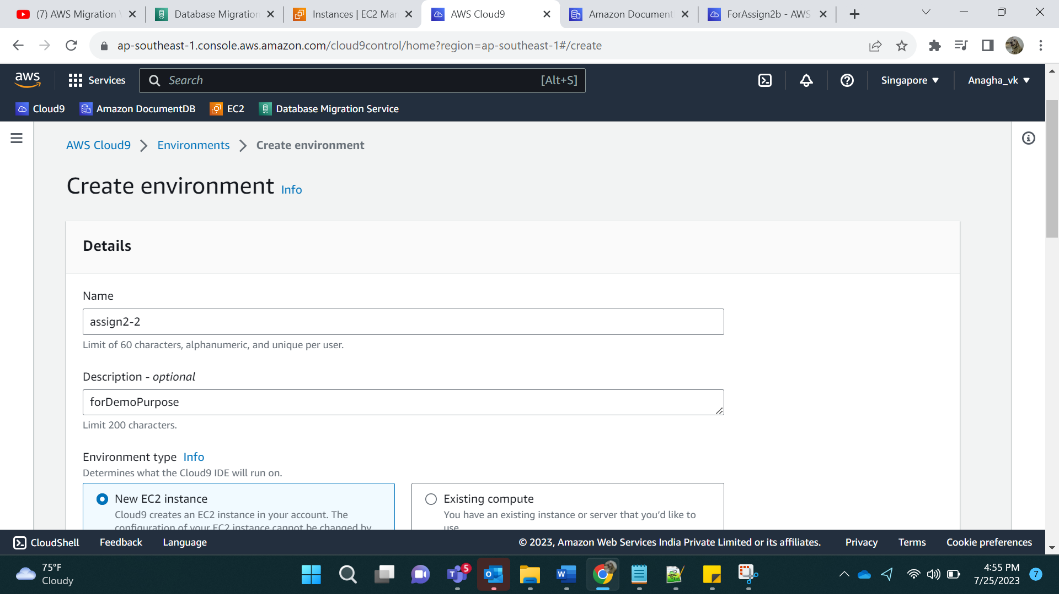

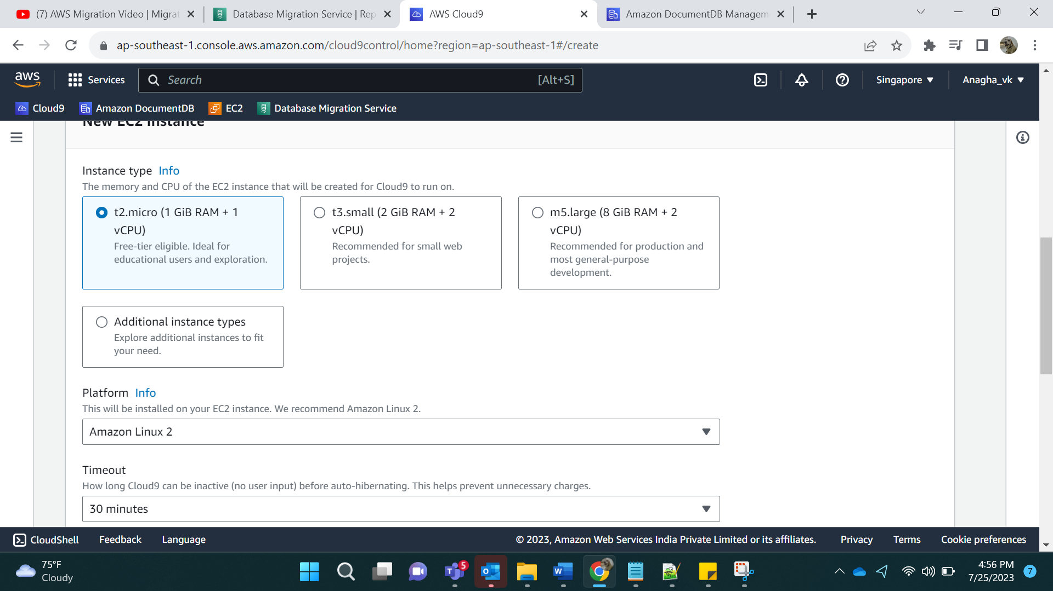

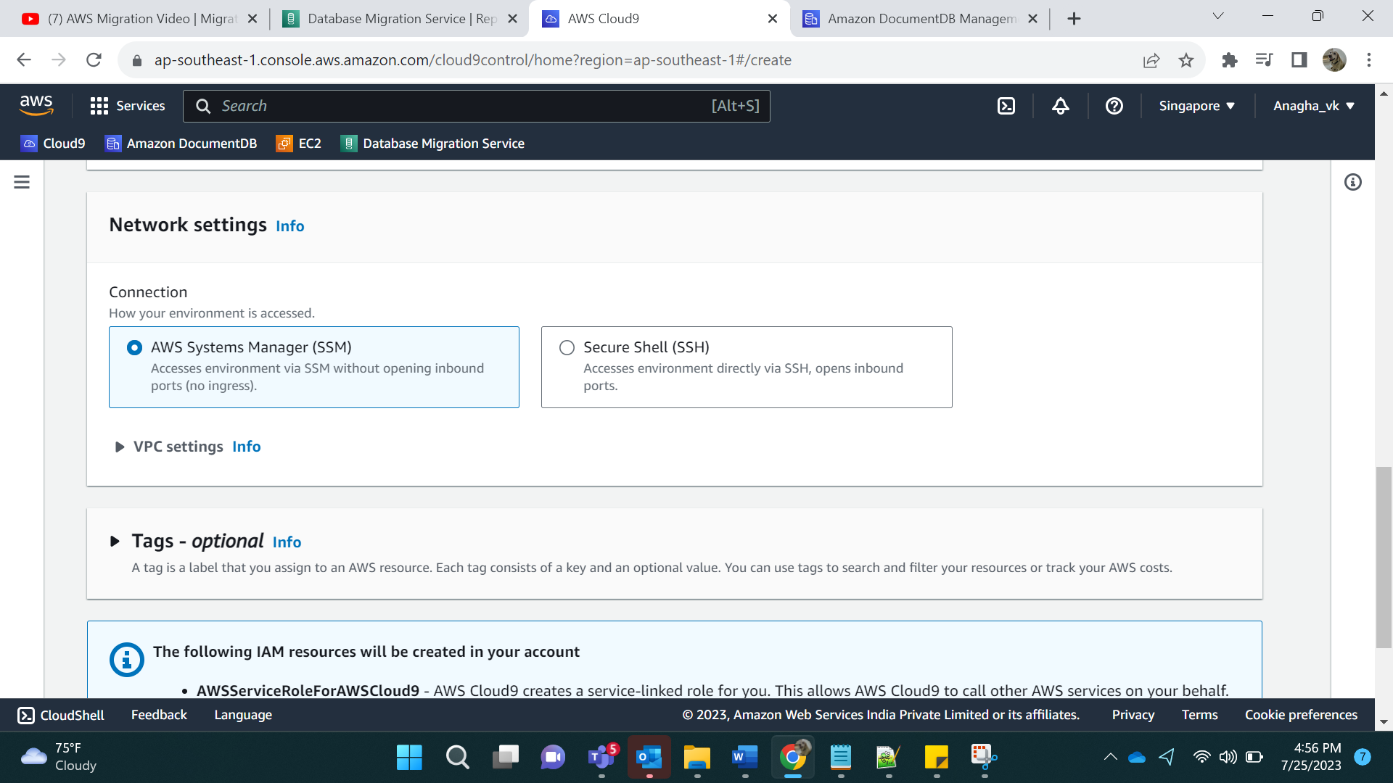

Click on Create

Click on Open IDE

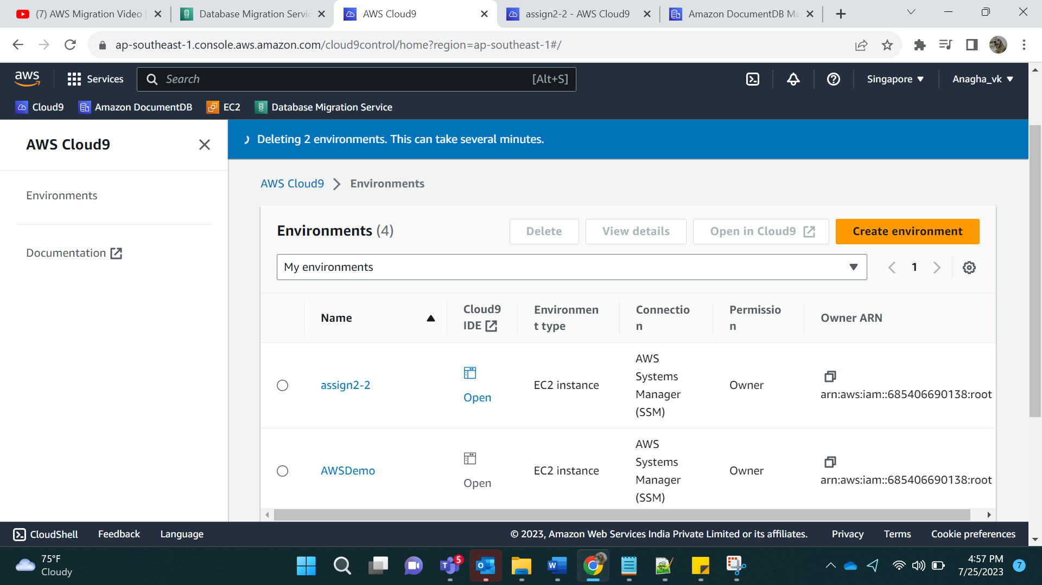

Step 2: Install mongo.

At the command prompt, create the repository file with the following command:

sudo su –

cd /etc/yum.repos.d

vi mongodborg-4.0.repo

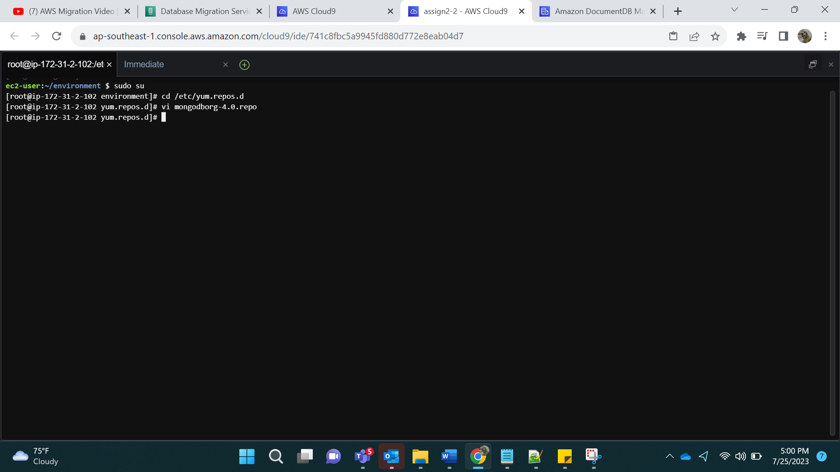

[mongodb-org-4.0]  
name=MongoDB Repository  
baseurl=<https://repo.mongodb.org/yum/amazon/2013.03/mongodb-org/4.0/x86_64/>  
gpgcheck=1  
enabled=1  
gpgkey=<https://www.mongodb.org/static/pgp/server-4.0.asc>

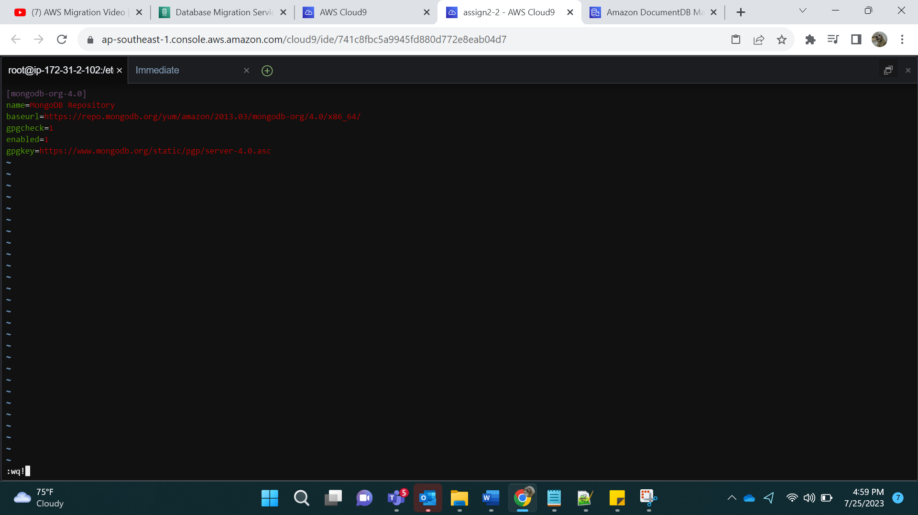

Save(wq!) the file and install the mongo shell.

sudo yum install -y mongodb-org

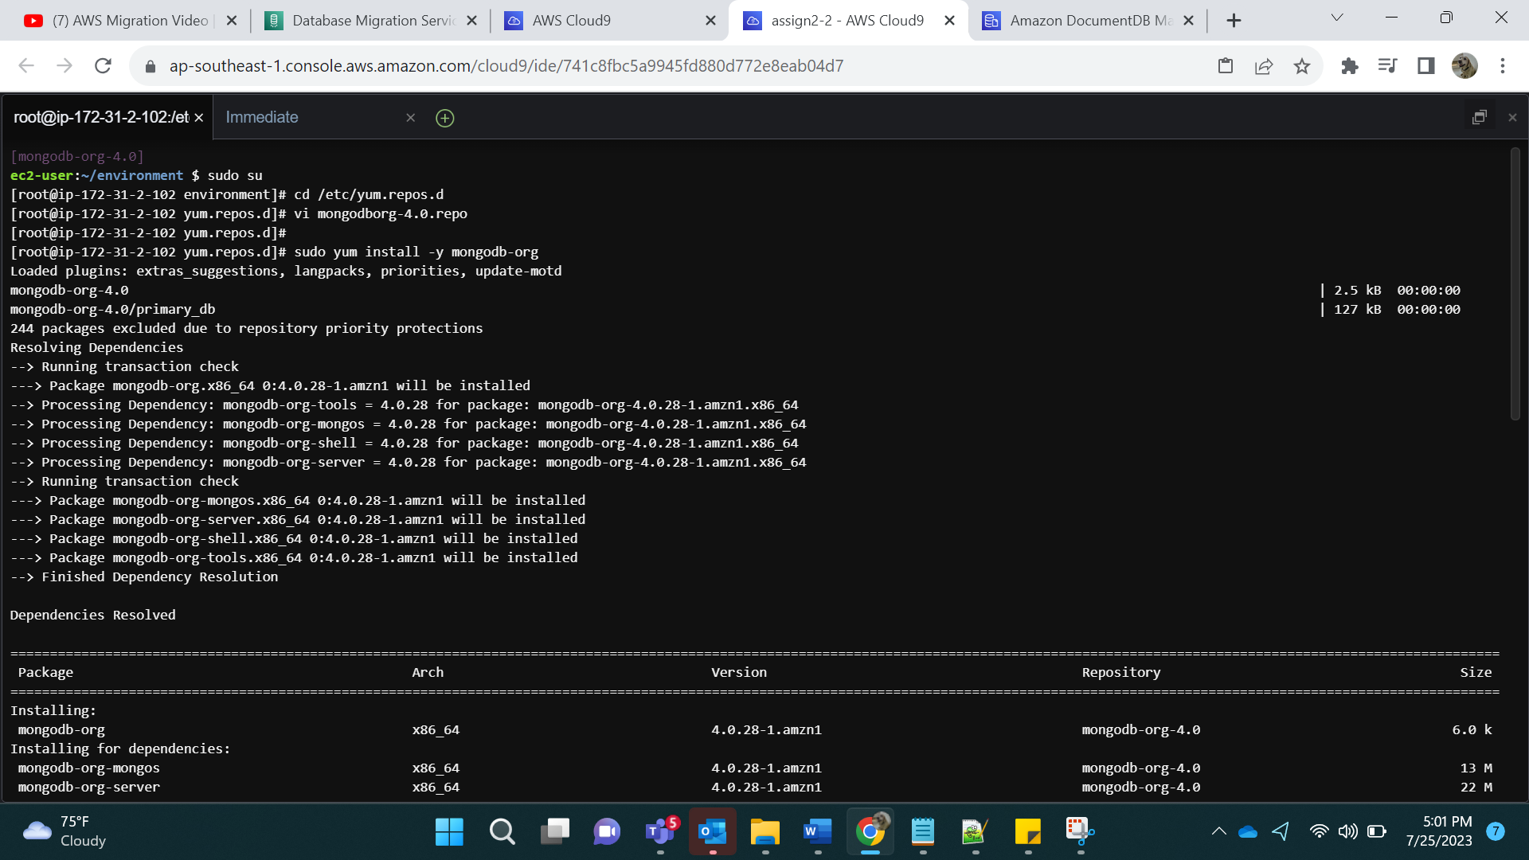

Completed Installation

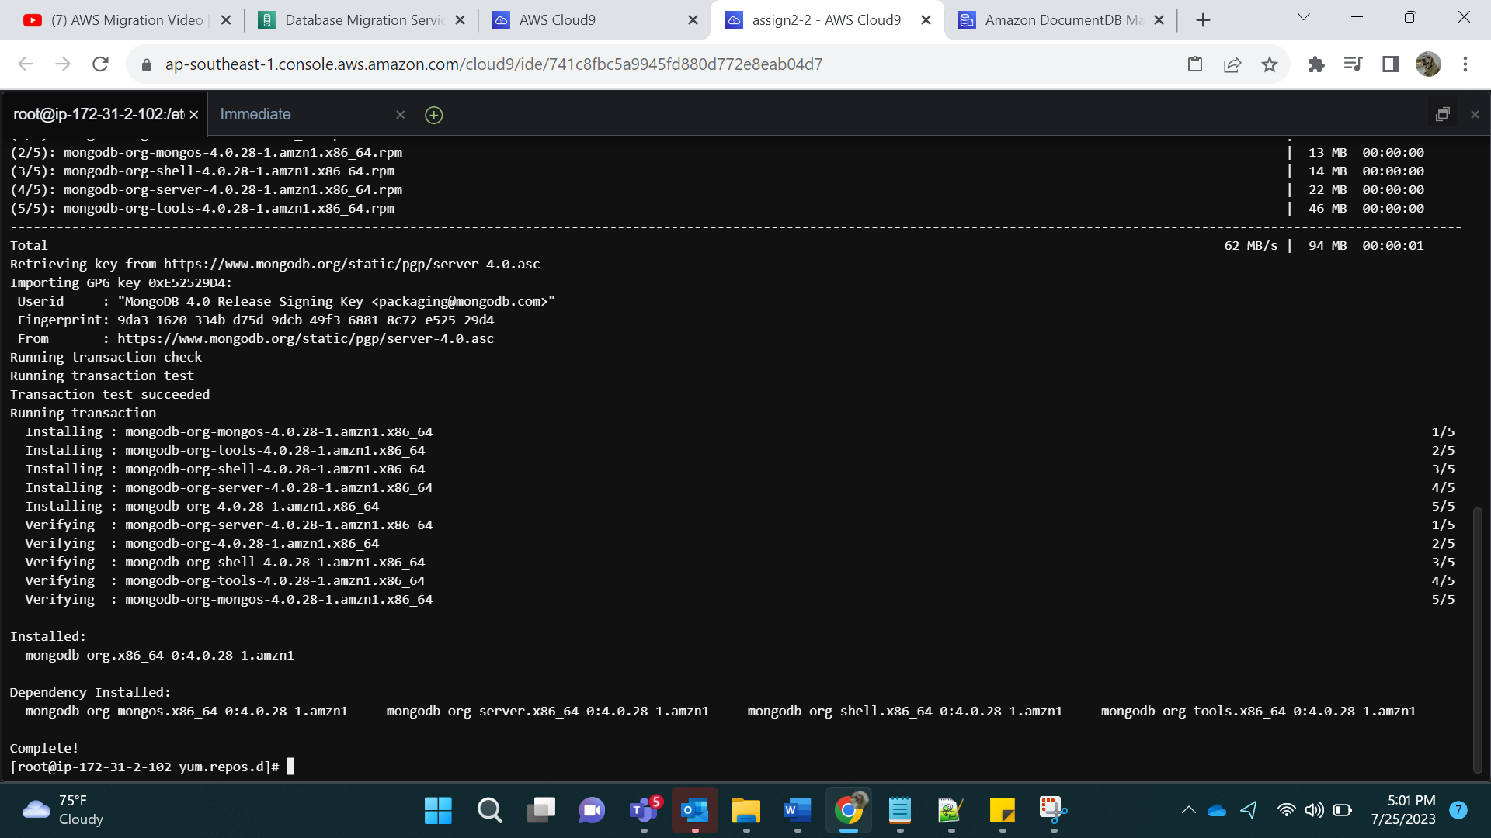

Starting the mongod service and checking if mongo services are working.

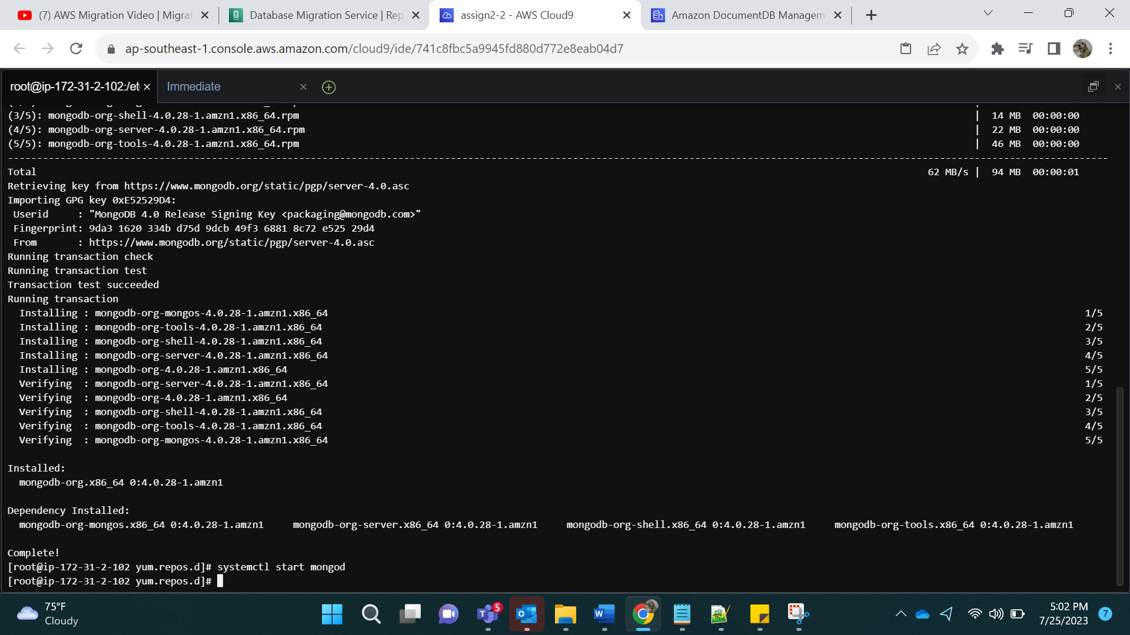

mongo

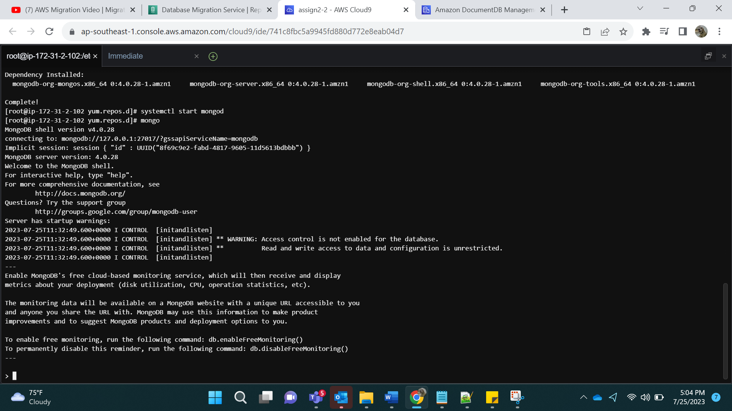

Step 3:

Changing the IPv4 id

Stopping the mongo service and editing the mongod.conf file

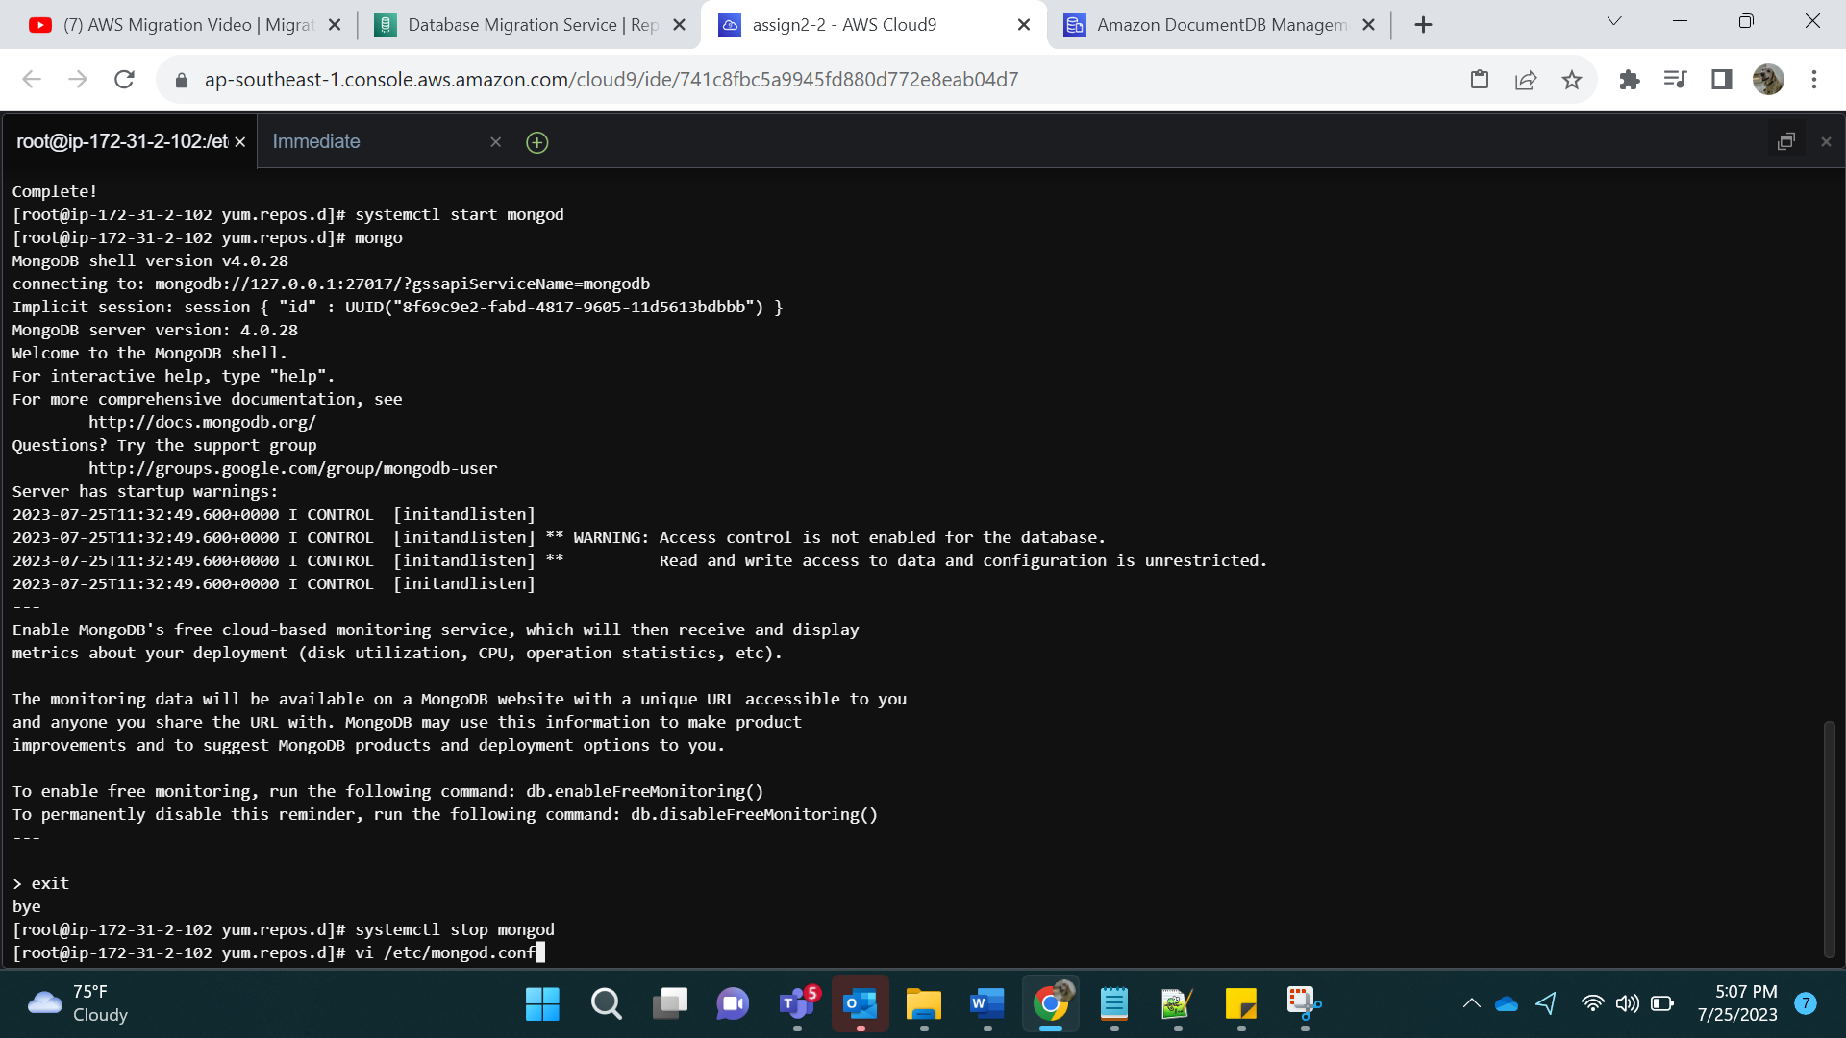

Before editing: BindIp is mentioned

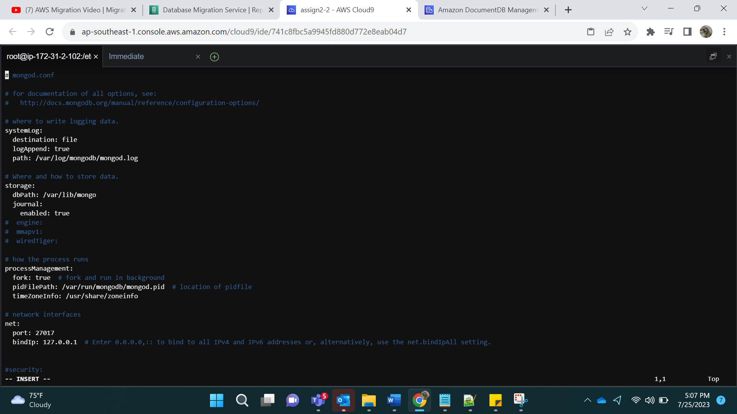

Click on I(for insert)

After editing: copy the public IPv4 DNS of the created EC2 instance.

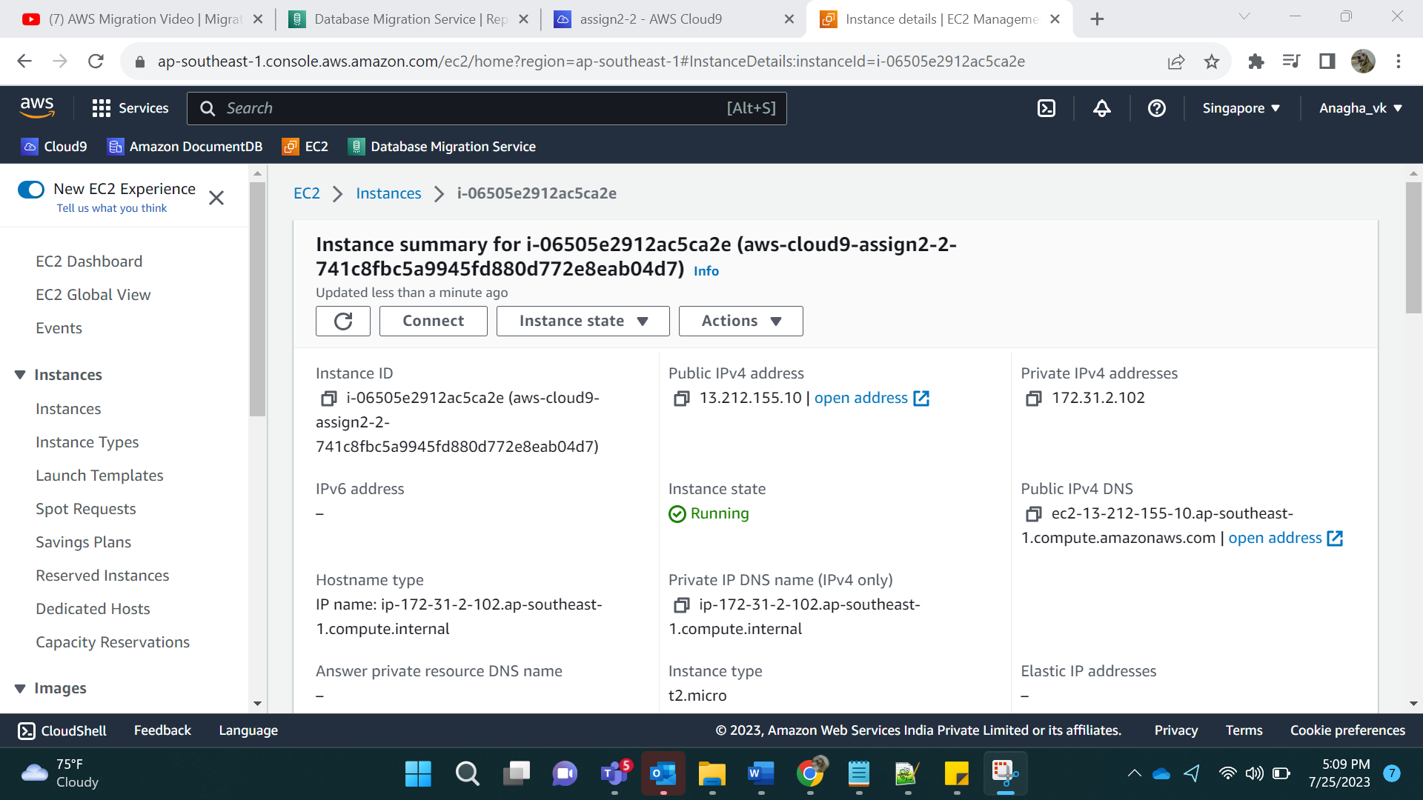

Type wq! And enter

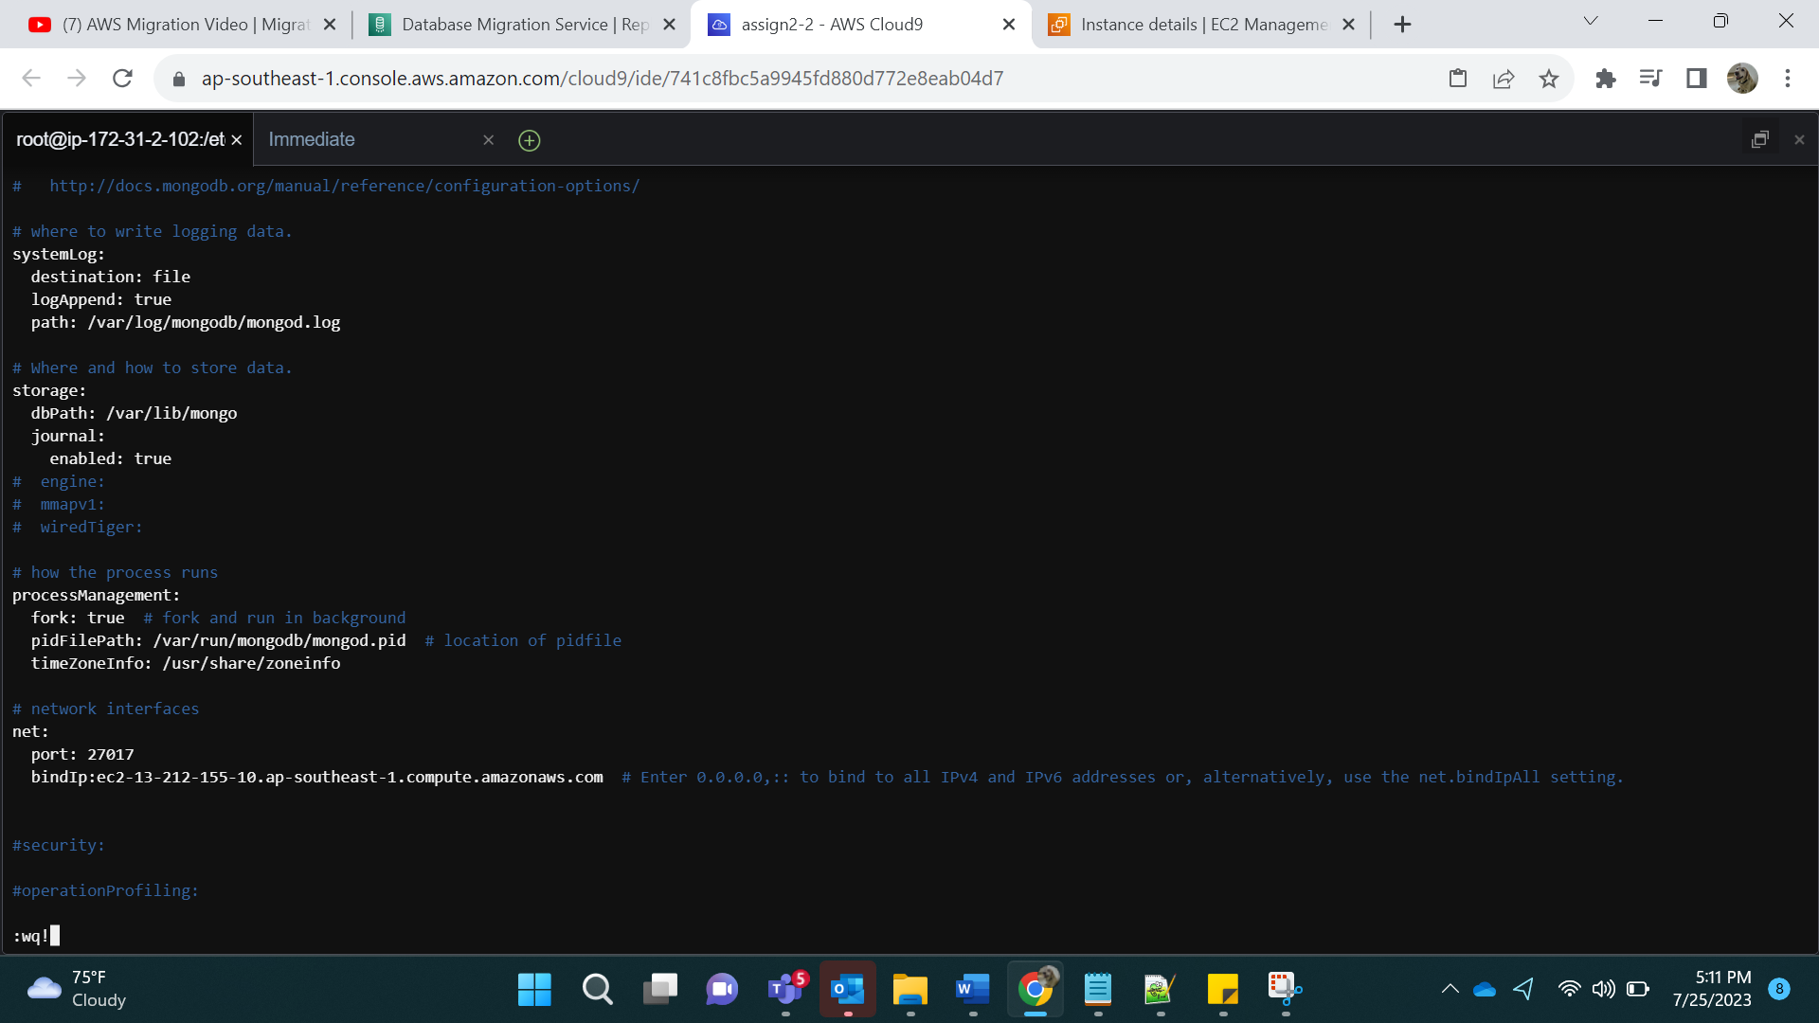

Step 4:

Execute the command:

mongod -f /etc/mongod.conf

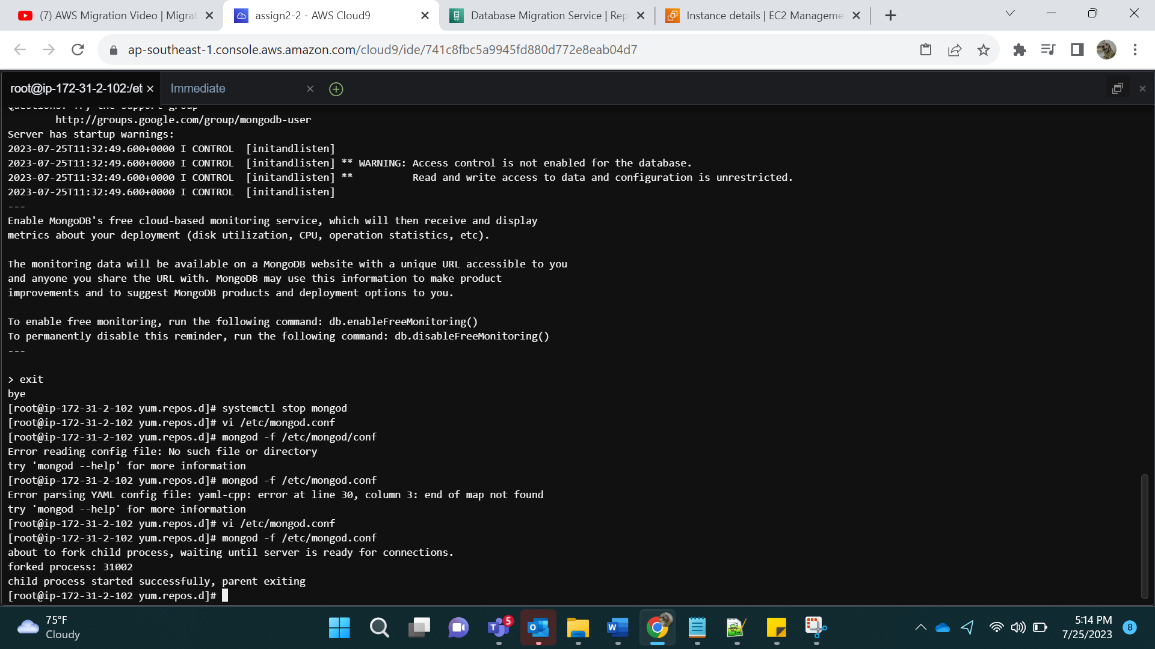

Step 5: Logging in Via host

mongo --host ec2-13-212-155-10.ap-southeast-1.compute.amazonaws.com

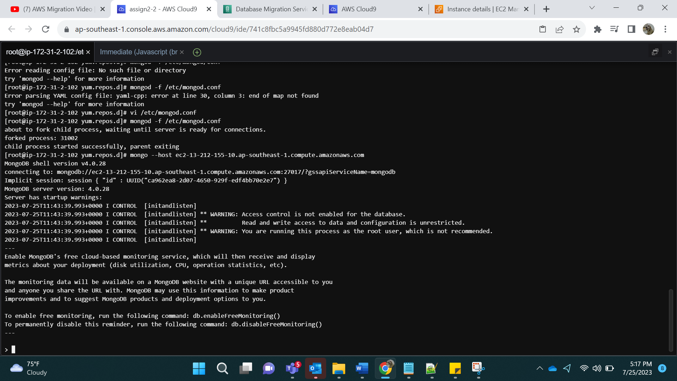

Step 6:

Adding data:

Use db1

db.table1.insertMany([

{ "_id" : 1, "name" : "Ajay", "status": "active", "level": 9,"score":99},

{ "_id" : 2, "name" : "Priya", "status": "inactive", "level": 5,"score":88}

])

db.table2.insertMany([

{ "_id" : 1, "name" : "Ashish", "status": "active", "level": 10,"score":100},

{ "_id" : 2, "name" : "Santwana", "status": "inactive", "level": 8,"score":50}

])

Use db2

db.table3.insertMany([

{ "_id" : 1, "name" : "Amruta", "status": "active", "level": 1,"score":40},

{ "_id" : 2, "name" : "Avadhoot", "status": "inactive", "level": 4,"score":60}

])

db.table4.insertMany([

{ "_id" : 1, "name" : "Vaishnavi", "status": "active", "level": 8,"score":8},

{ "_id" : 2, "name" : "Abhishek", "status": "inactive", "level": 8,"score":9}

])

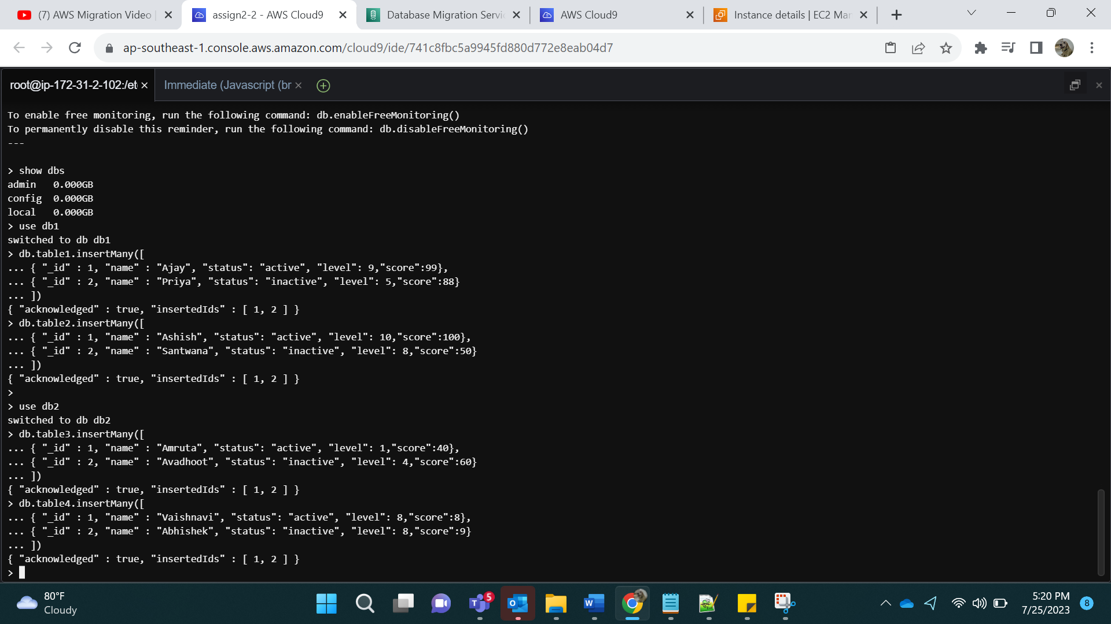

Step 7:

For replication purposes:

Following commands are used.

mongod -f /etc/mongod.conf –shutdown

mongod --replSet "rs0" --bind_ip ec2-13-212-155-10.ap-southeast-1.compute.amazonaws.com --dbpath /var/lib/mongo

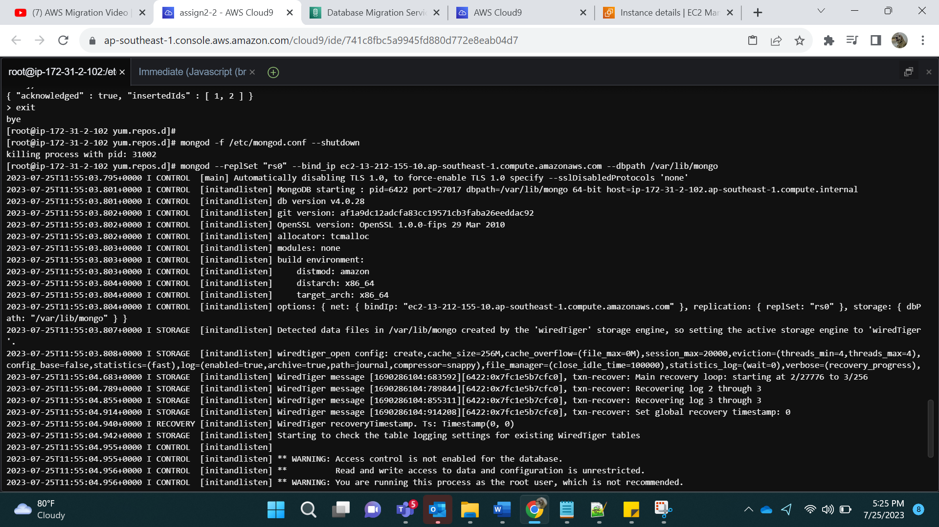

Step 8:

We will now open a new terminal in Cloud 9: (Alt-T)

Window 2:

mongo --host ec2-13-212-155-10.ap-southeast-1.compute.amazonaws.com

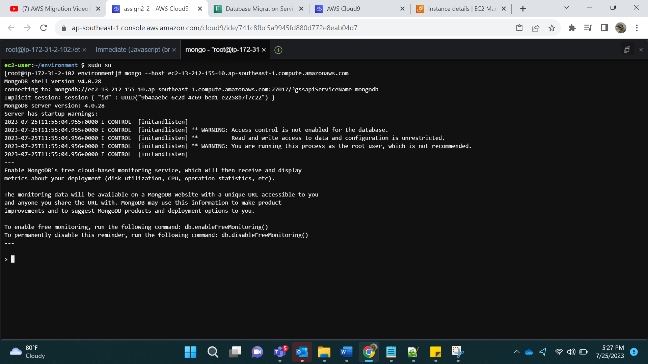

Step 9:

Command: rs.initiate() [initiates a replica set]

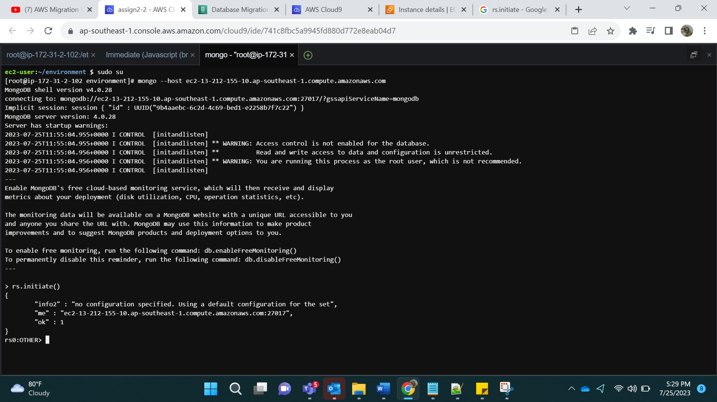

Rs.status():

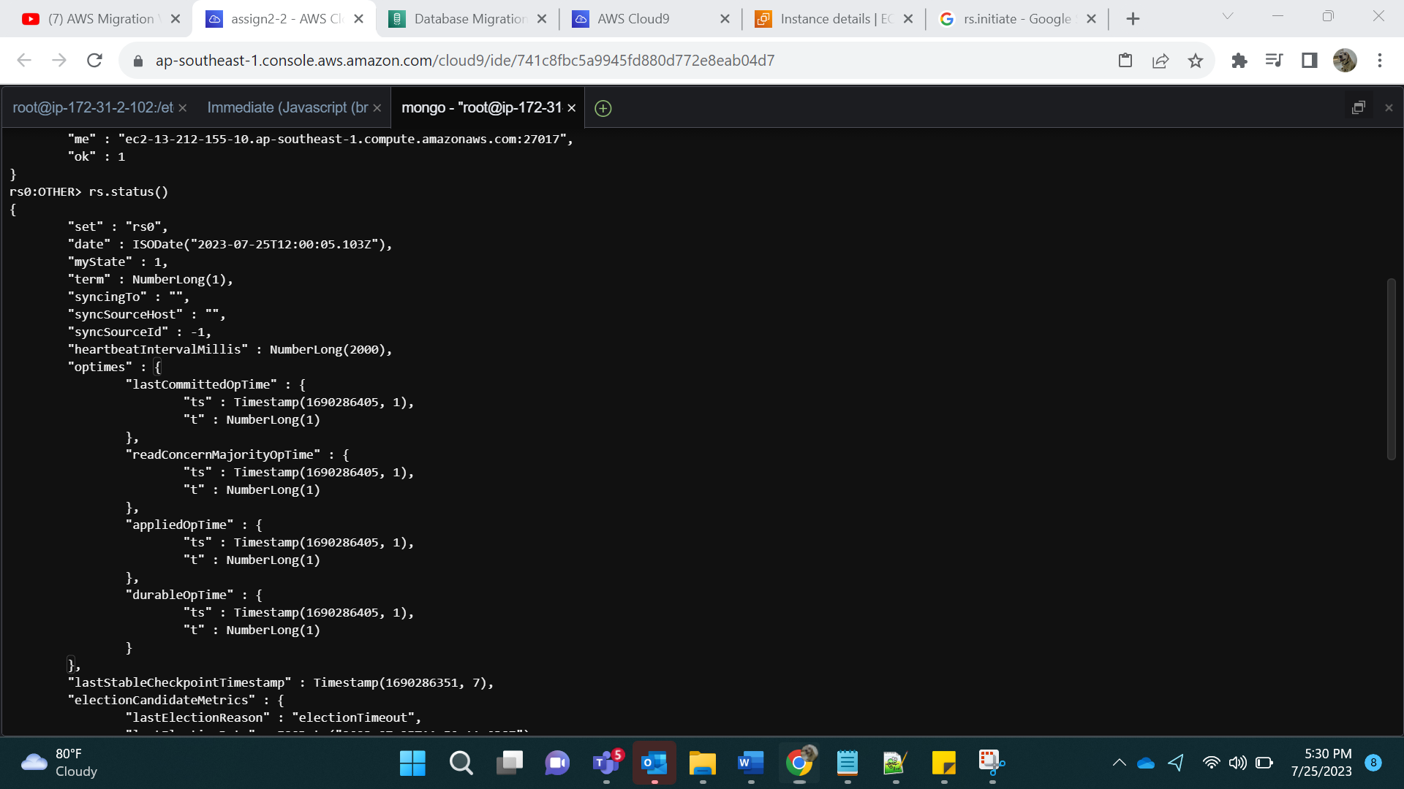

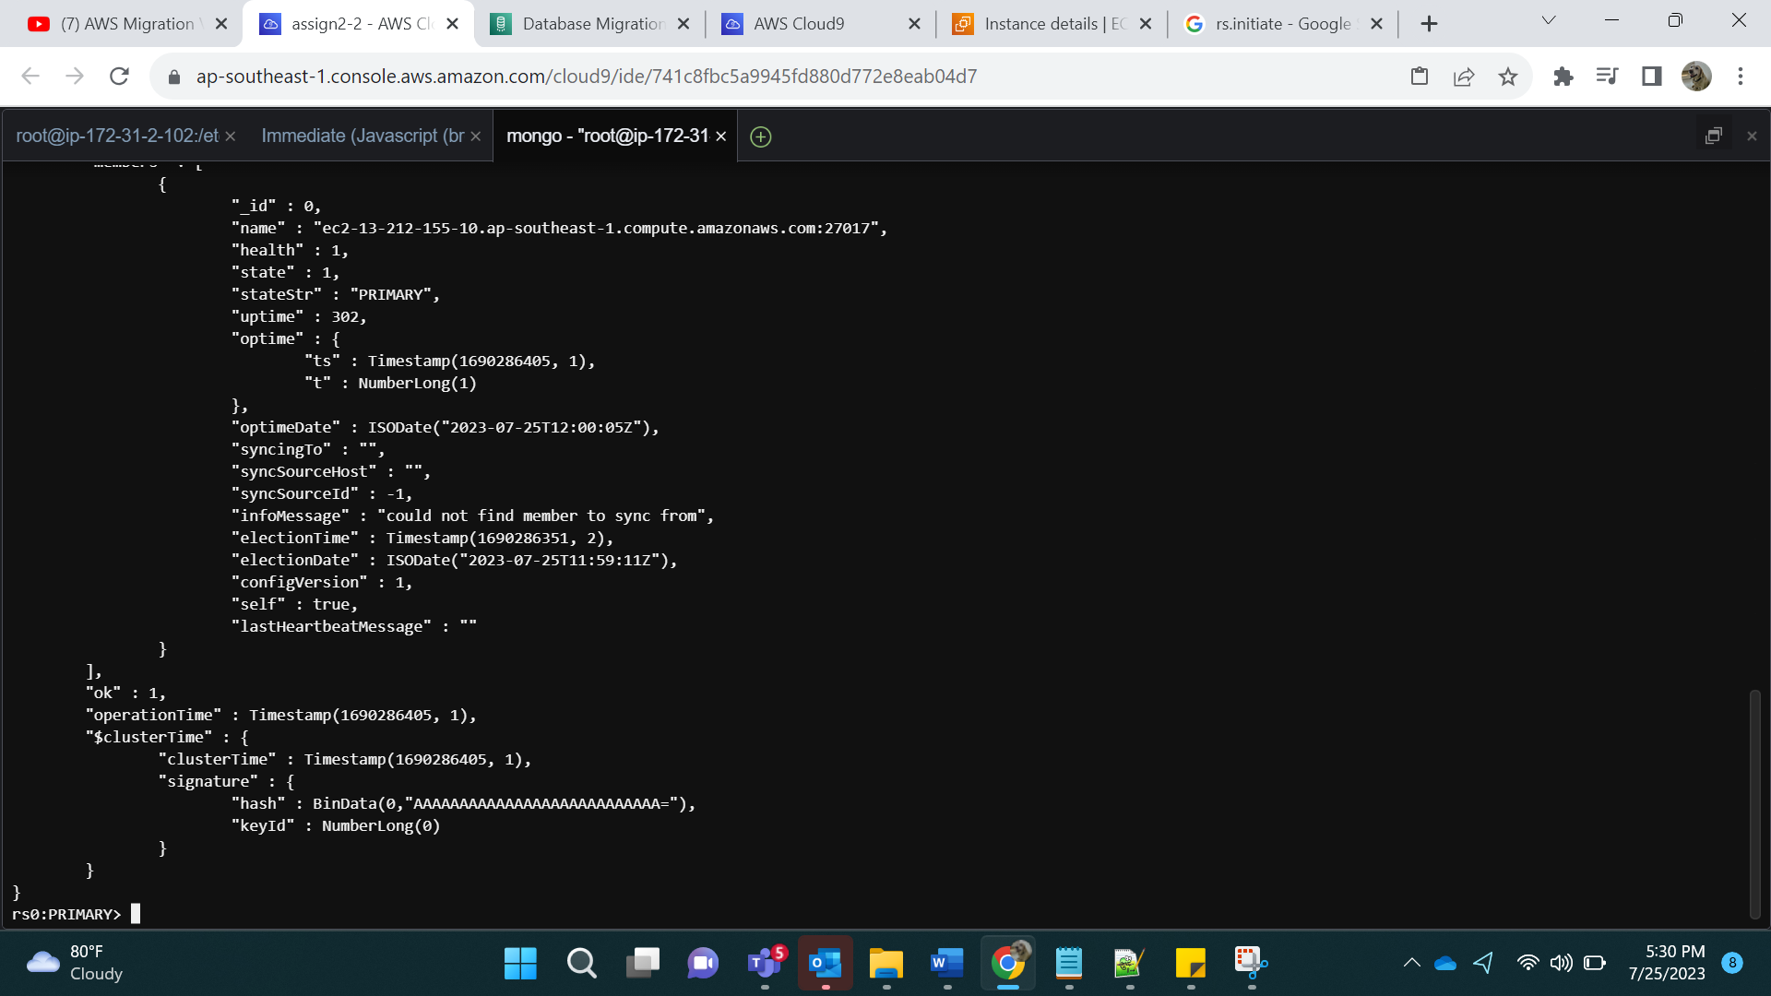

Show dbs:

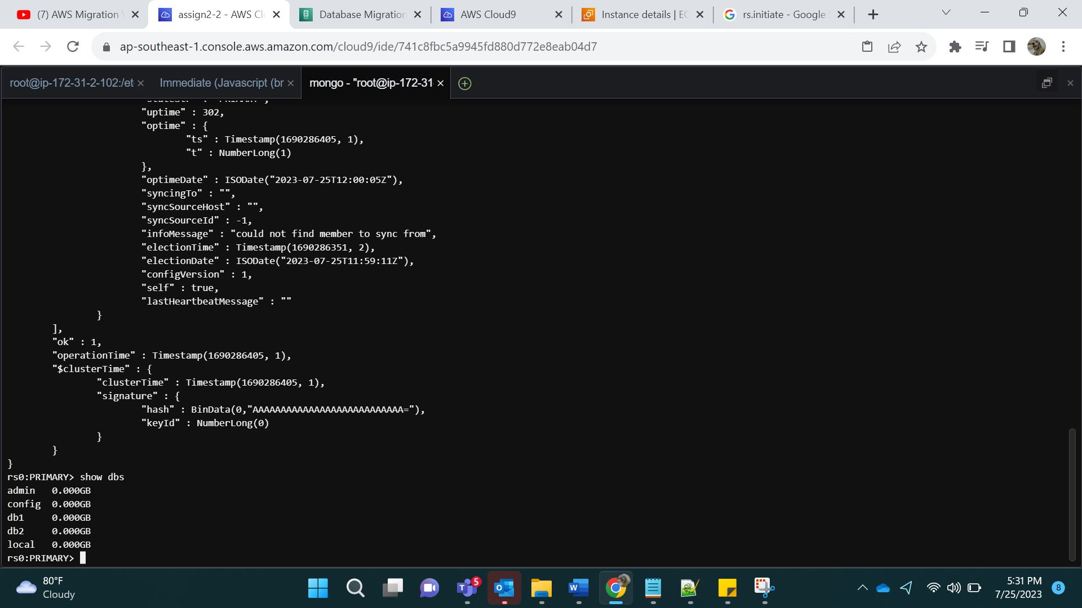

Step 10:

Logging by replica set:

mongo --host rs0/ec2-13-212-155-10.ap-southeast-1.compute.amazonaws.com

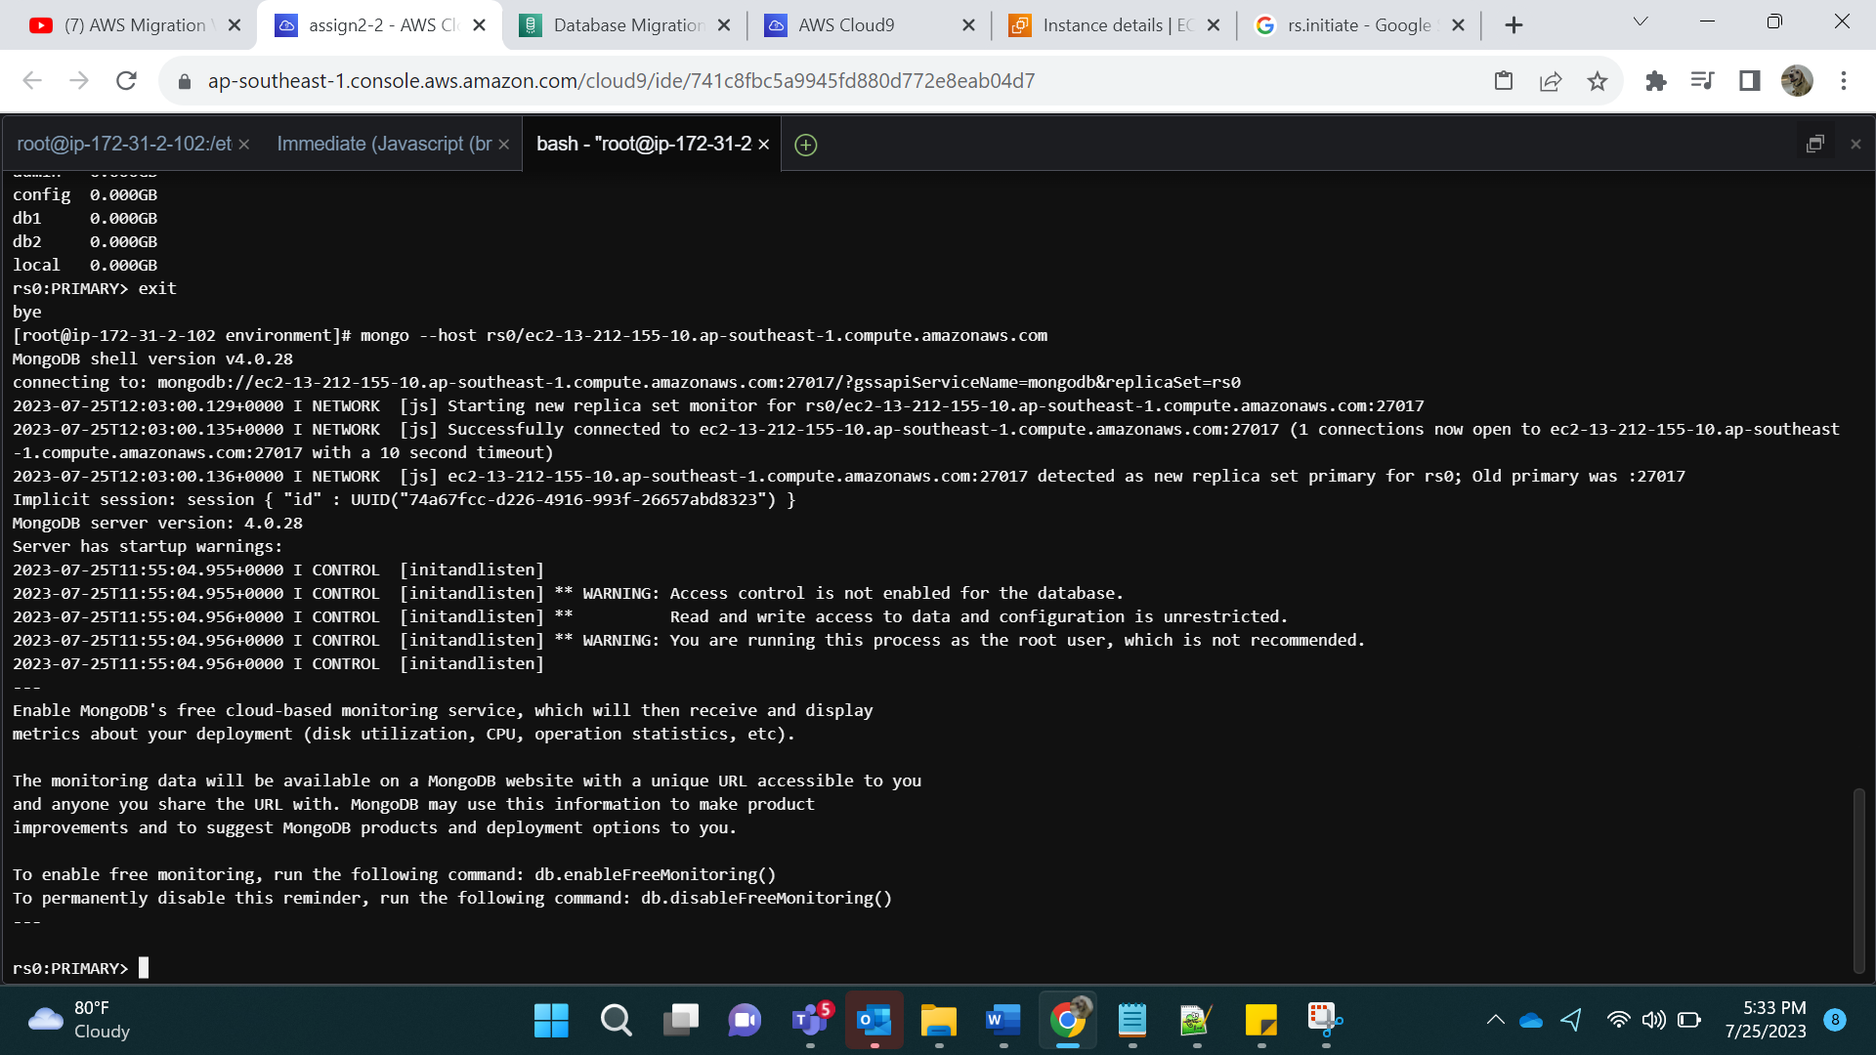

Show dbs;

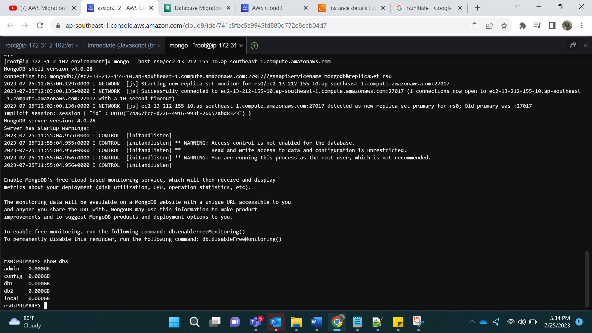

Step 11:

Creating Amazon DocDB Cluster

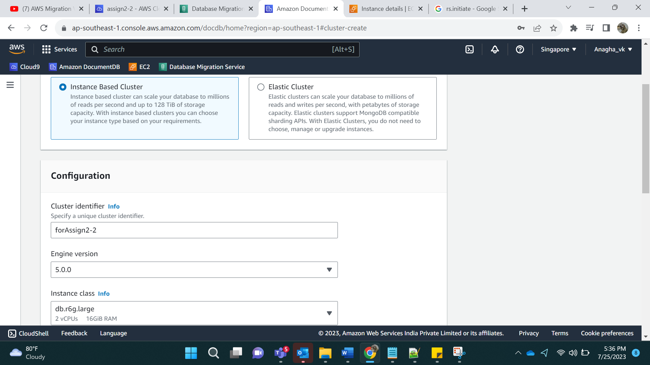

Number of instances: 1

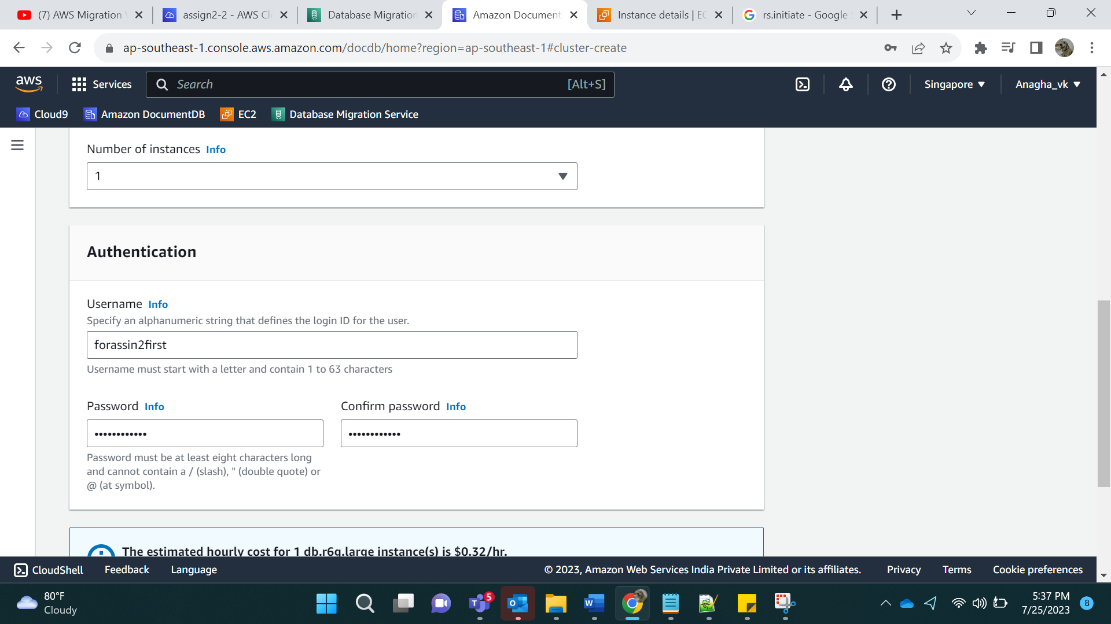

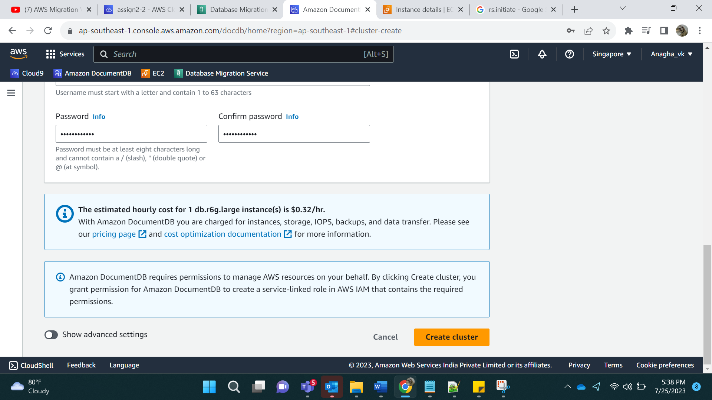

Create Cluster

Result:

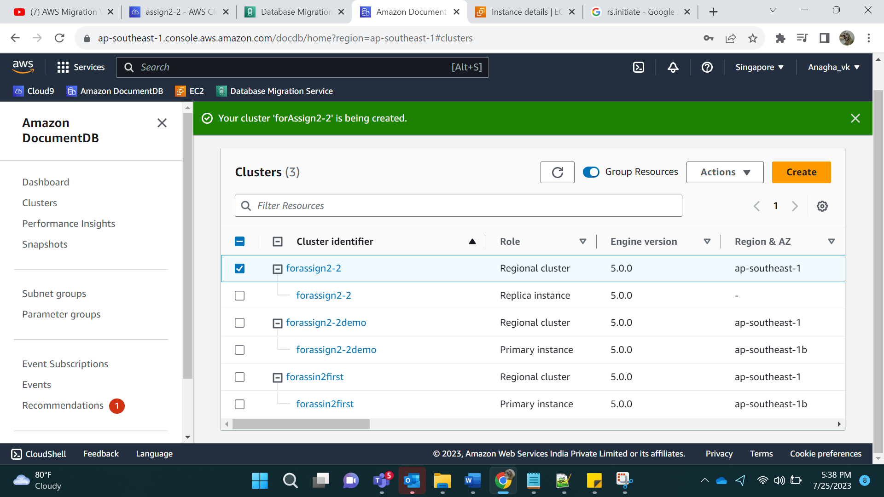

Step 12:

Download the pem file and also copy it into the console:

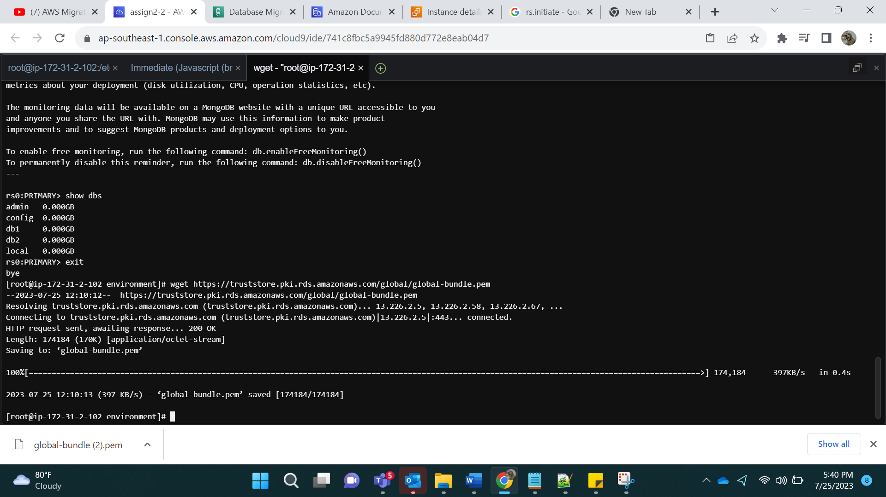

Logging in via Docdb:

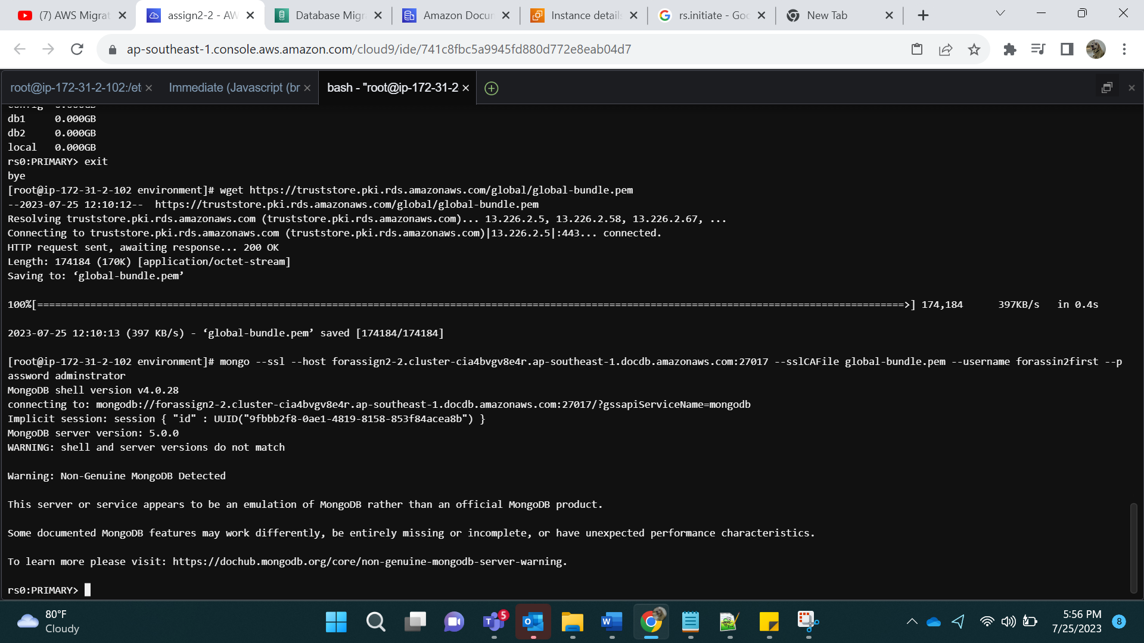

Step 13: Show dbs

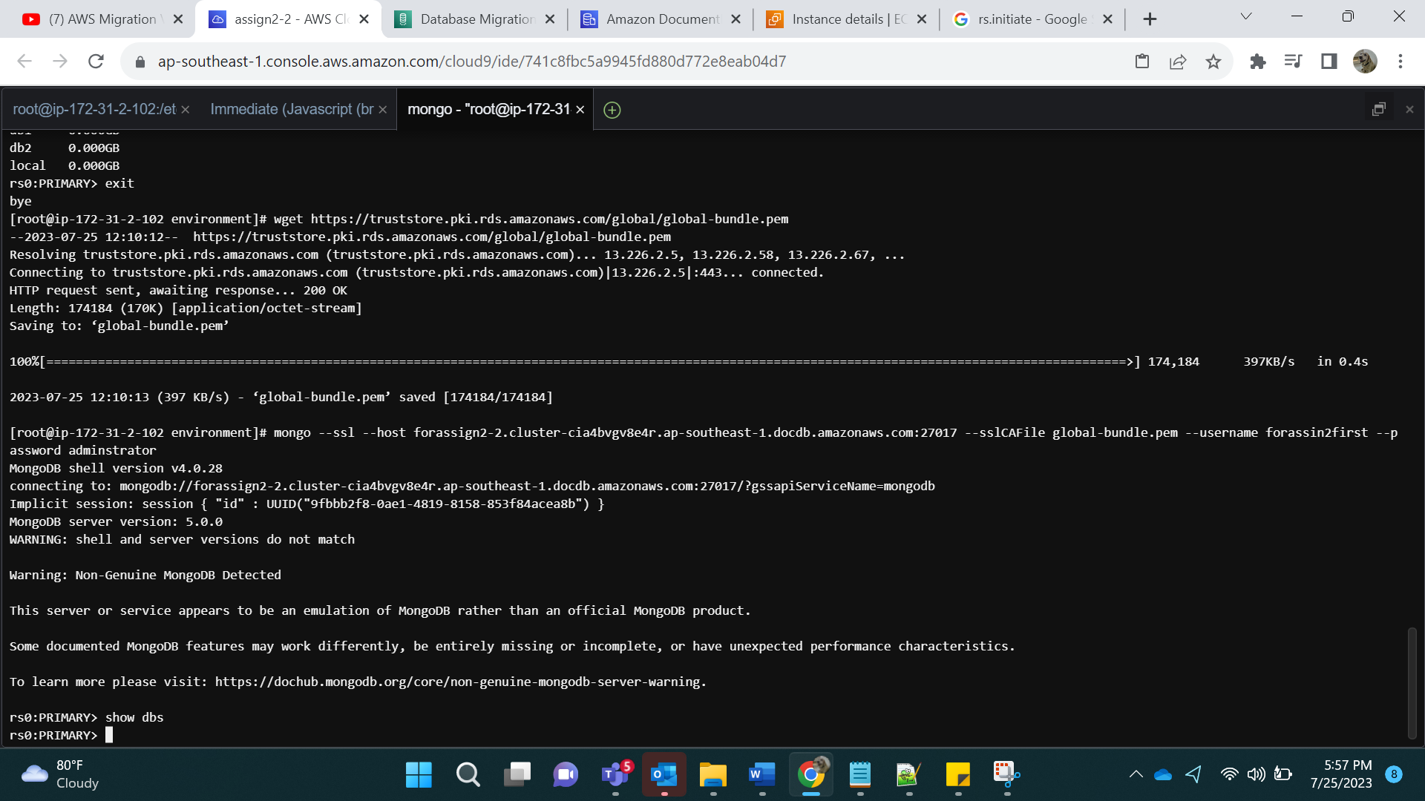

Step 14:

Now we create Replication instance in Database Migration Services (DMS).

Go to DMS-> Create replication instance:

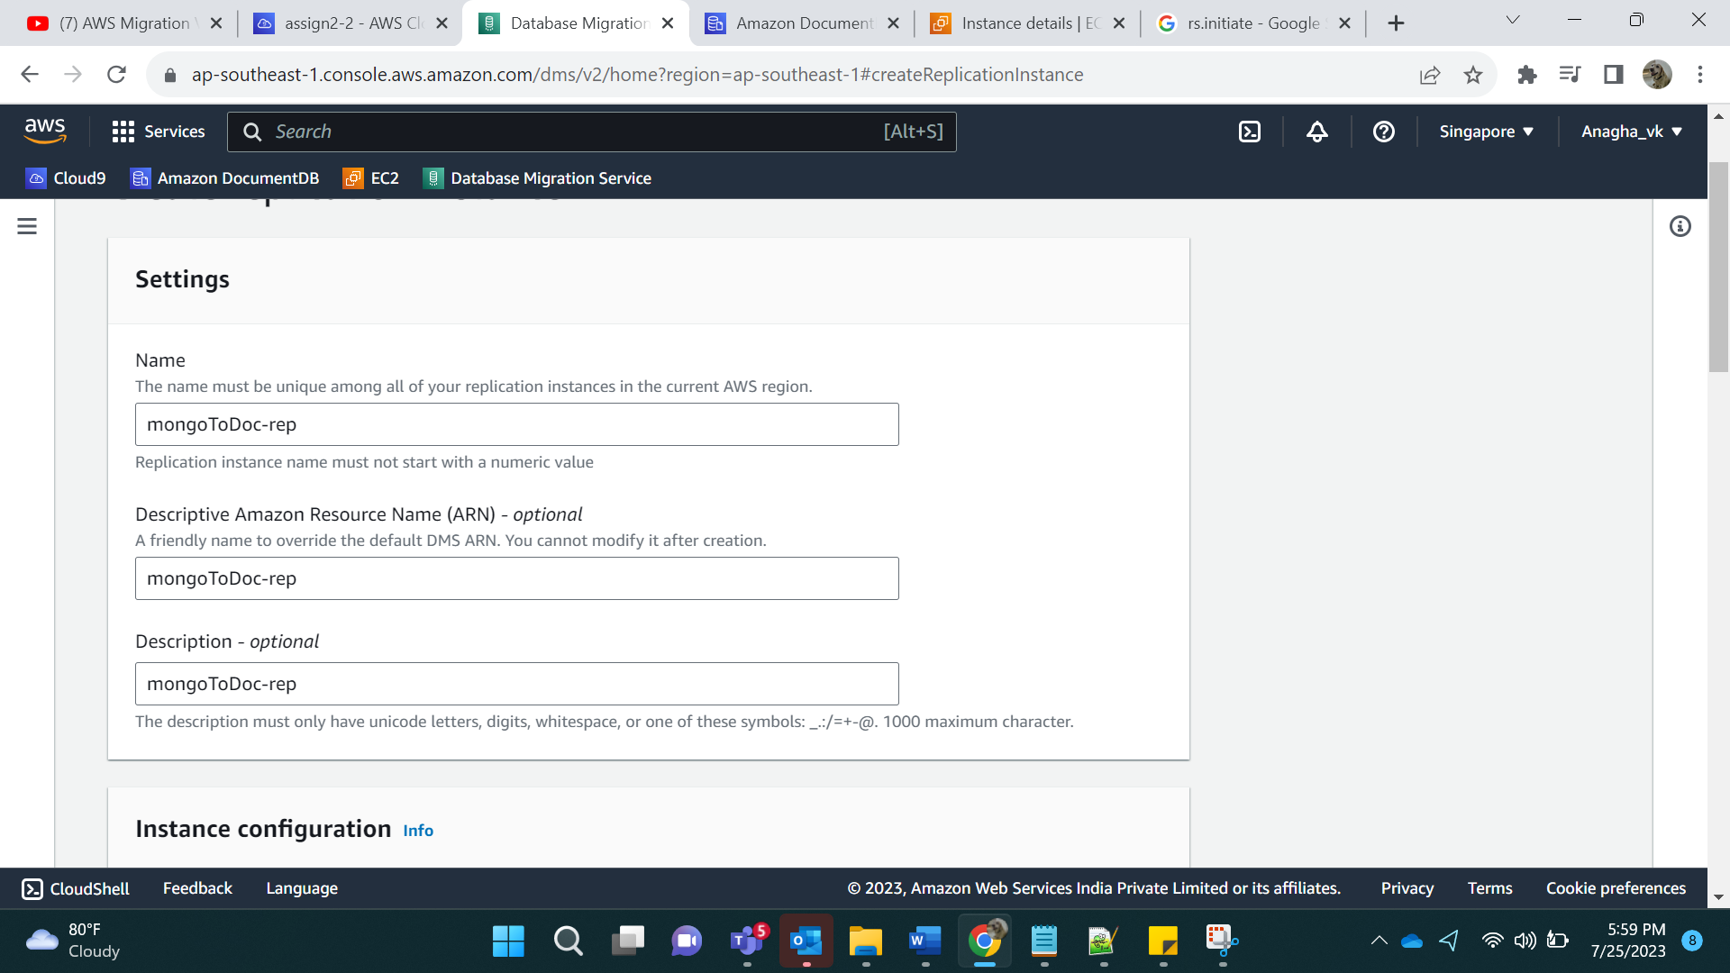

Select the least instance class and Single A-Z

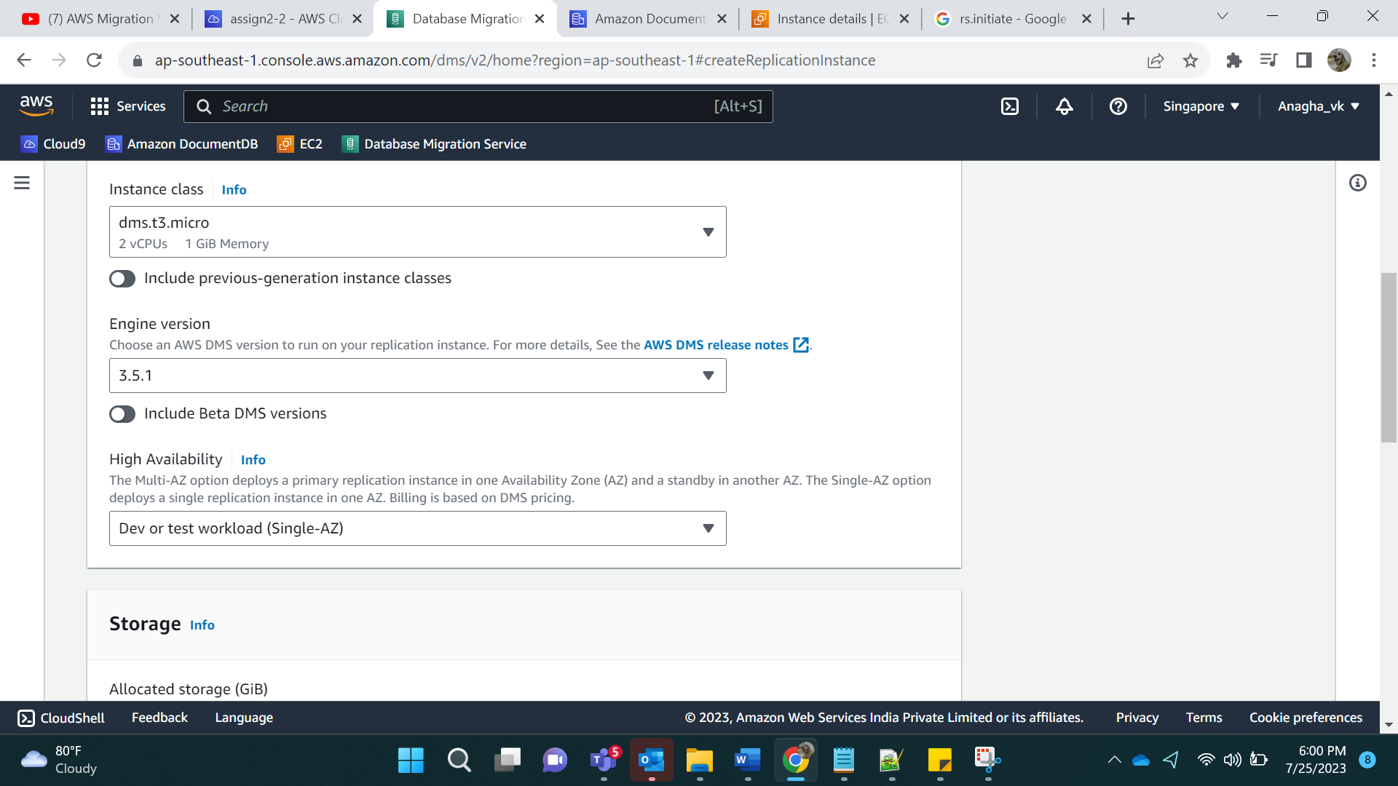

Storage reduced to 30 GB, vpc is default:

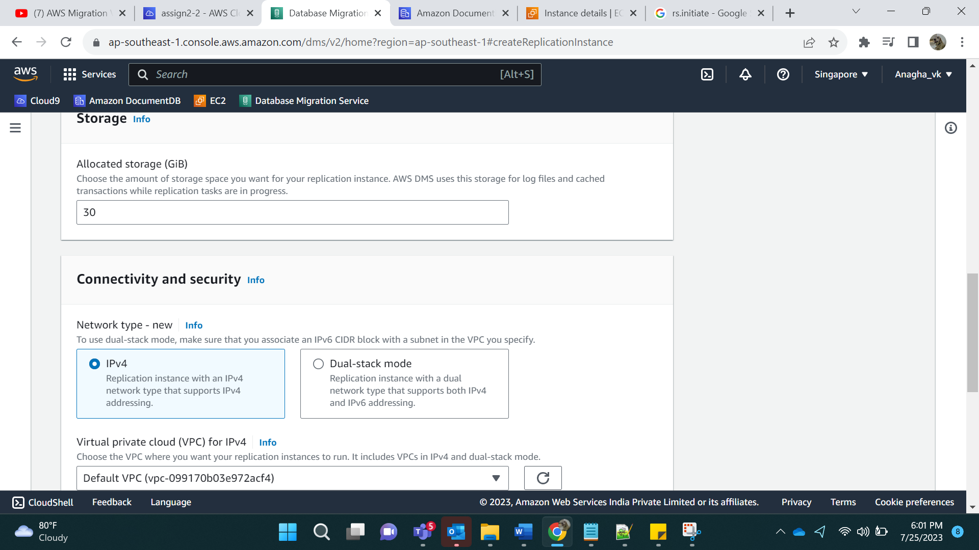

Create replication instance.

Step 15:

Create Endpoints.

1)Source

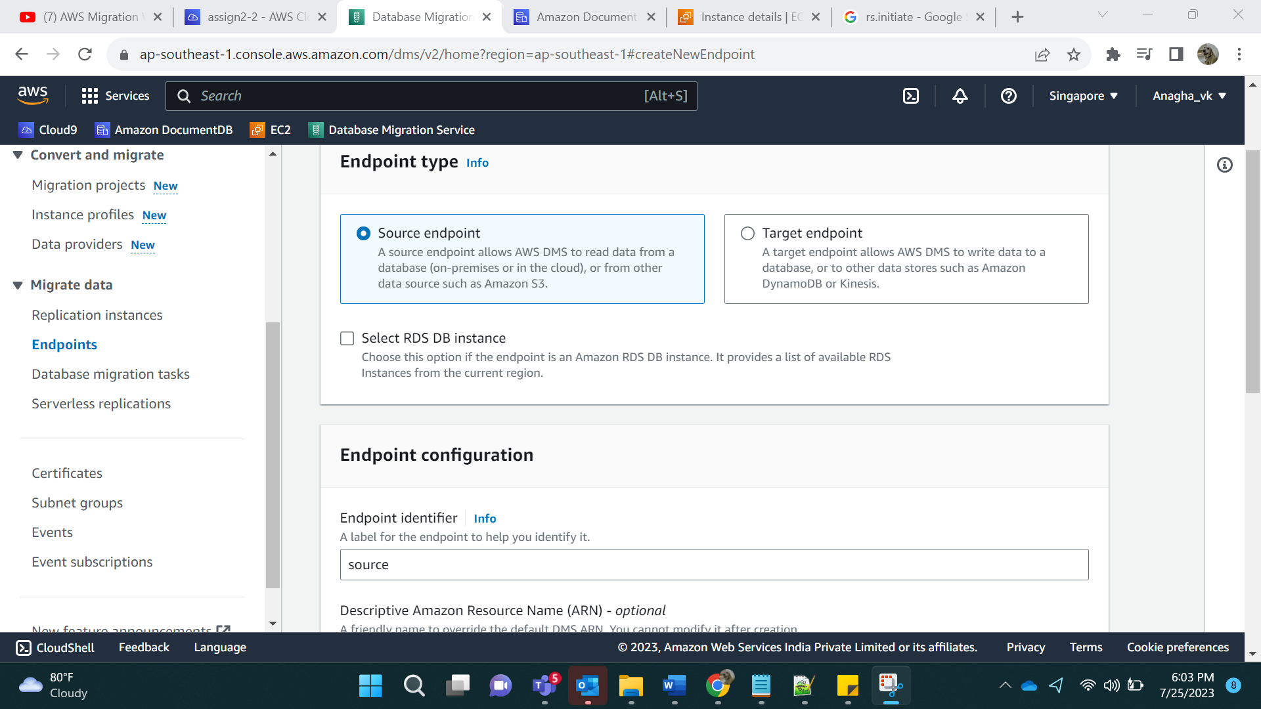

Arn: Source

Source Engine: MongoDB

Click on Provide access information manually.

Server Name: Ec2 instance IPv4 Public DNS

Port Number: 27017

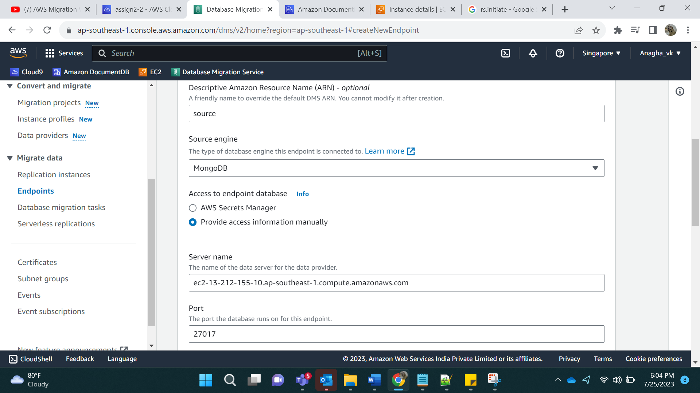

Database Name: db1

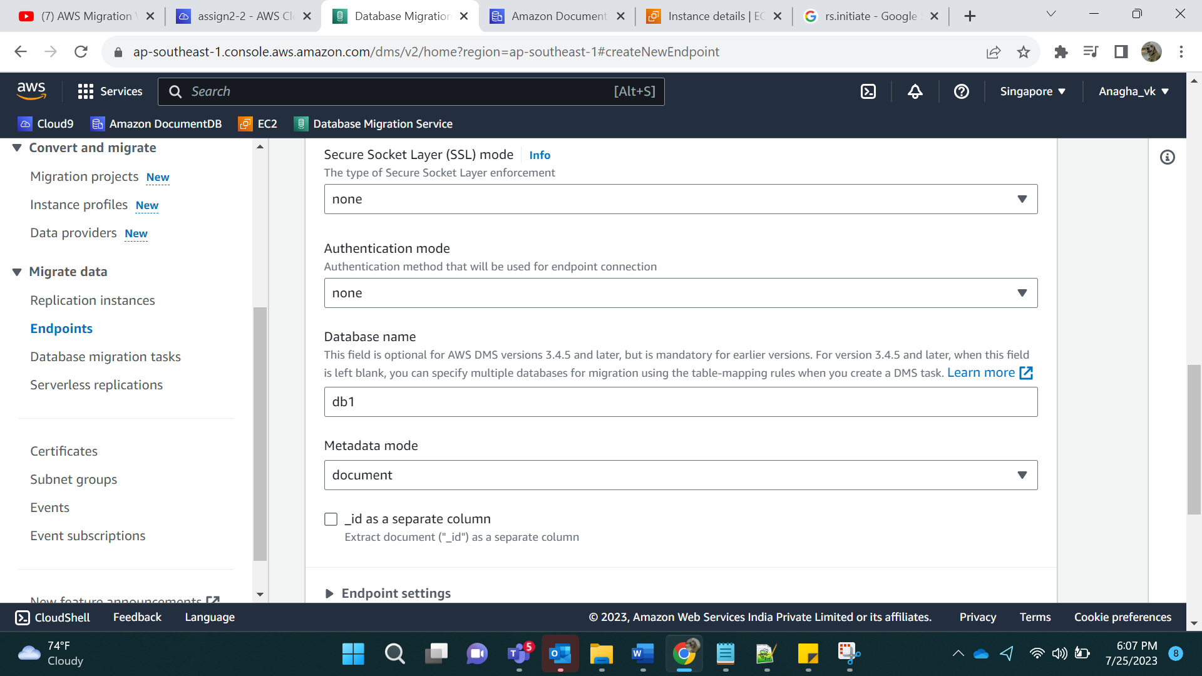

Output:

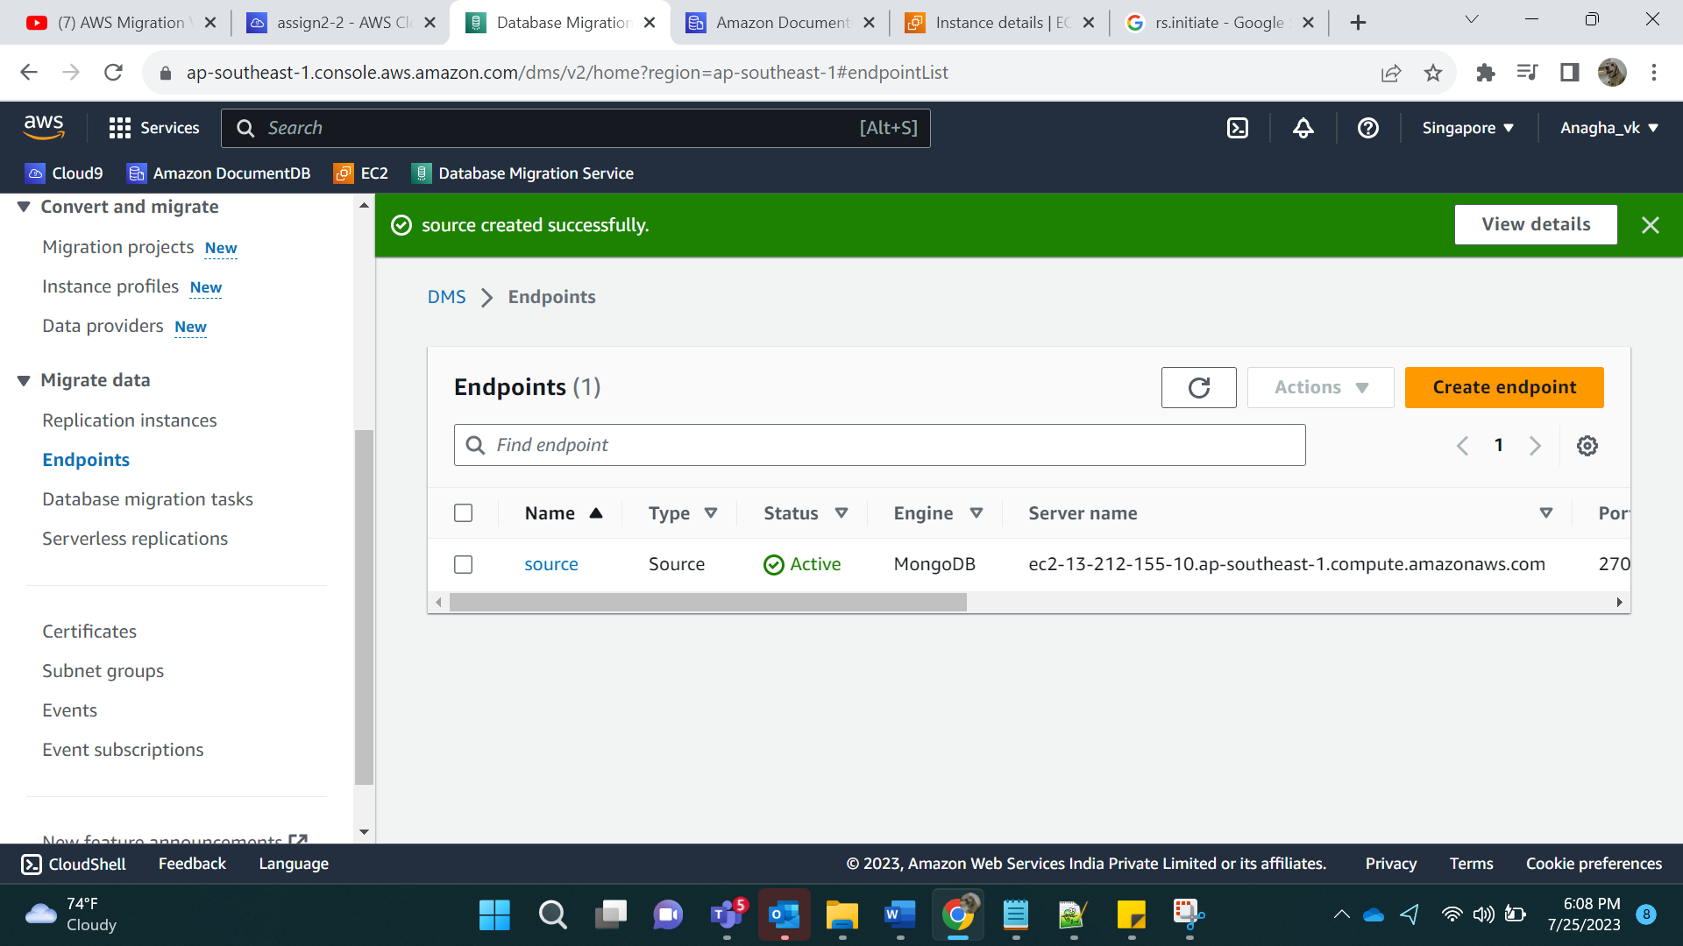

2)Target:

Label: target

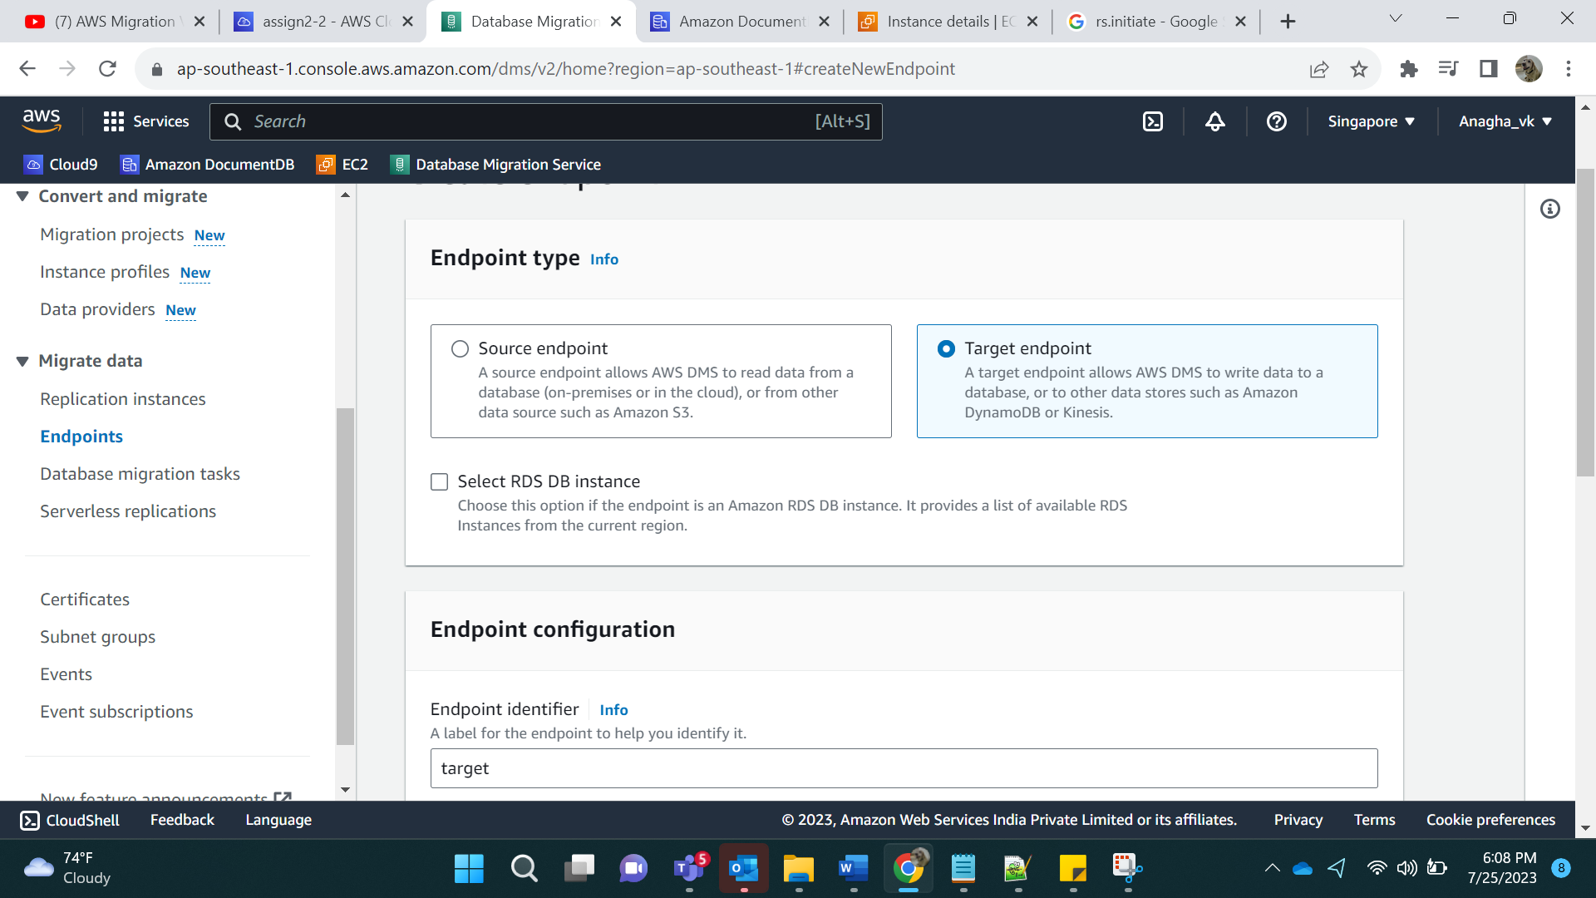

Arn: target

Target Engine: DocumentDB

Click on Provide access information manually.

Server name: Document DB name

Port: 27017

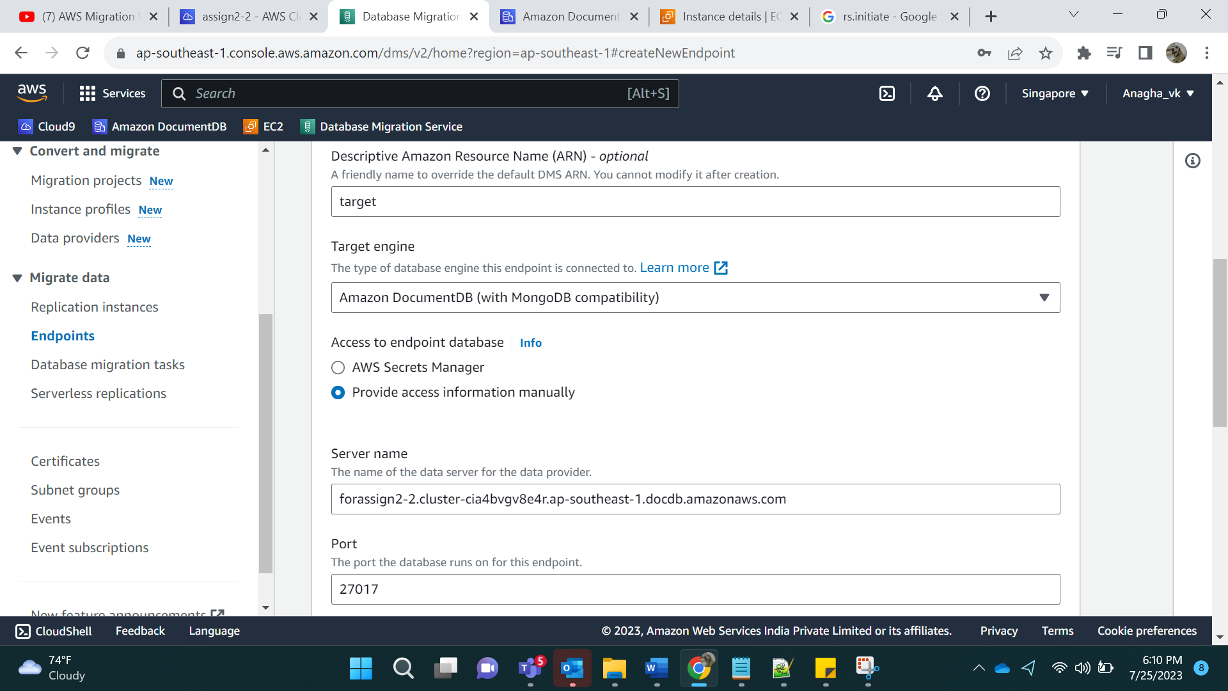

Login name:

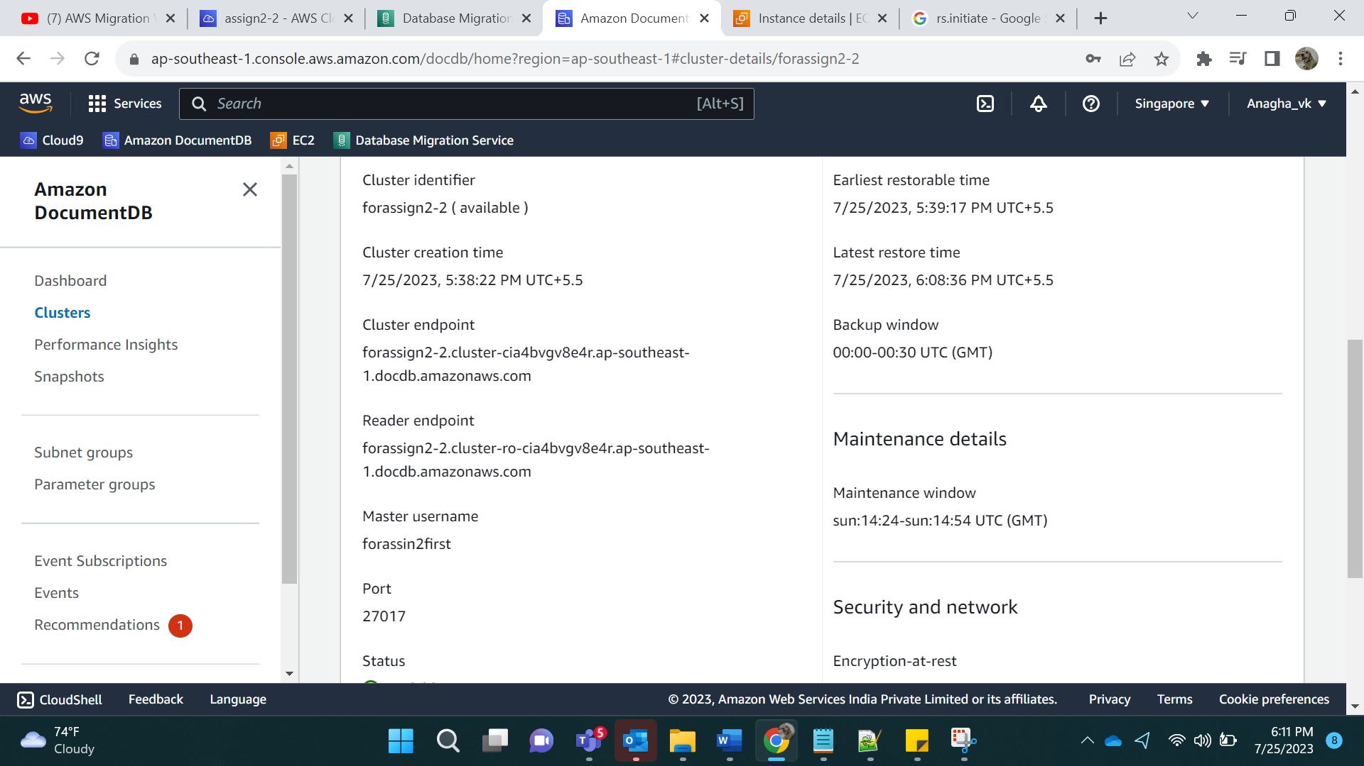

User name to be added, password as assigned.

SSL: verify full, Add the pem file in certificate. Add database name as db1.

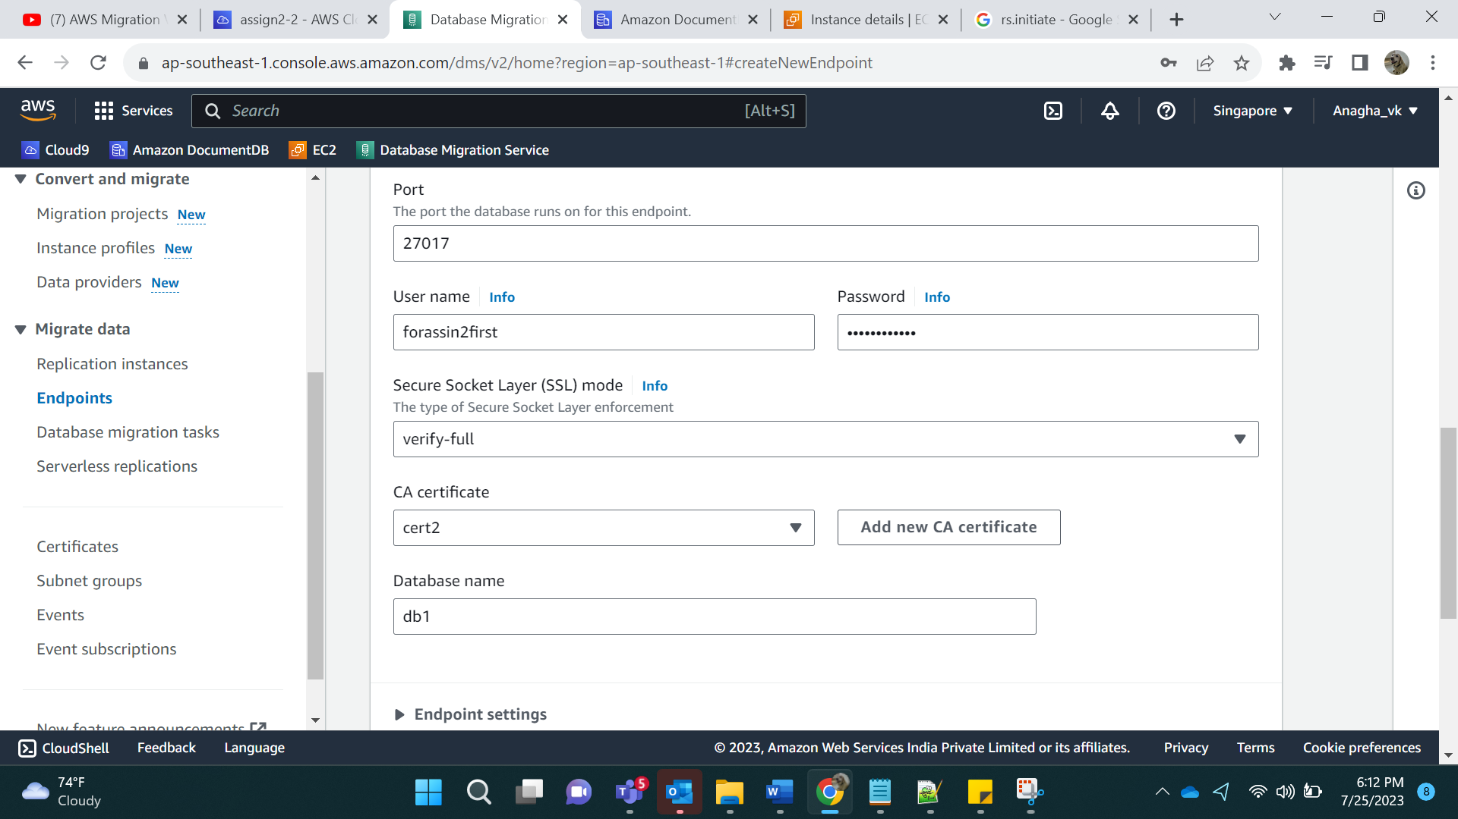

Step 16:

Test the endpoints:

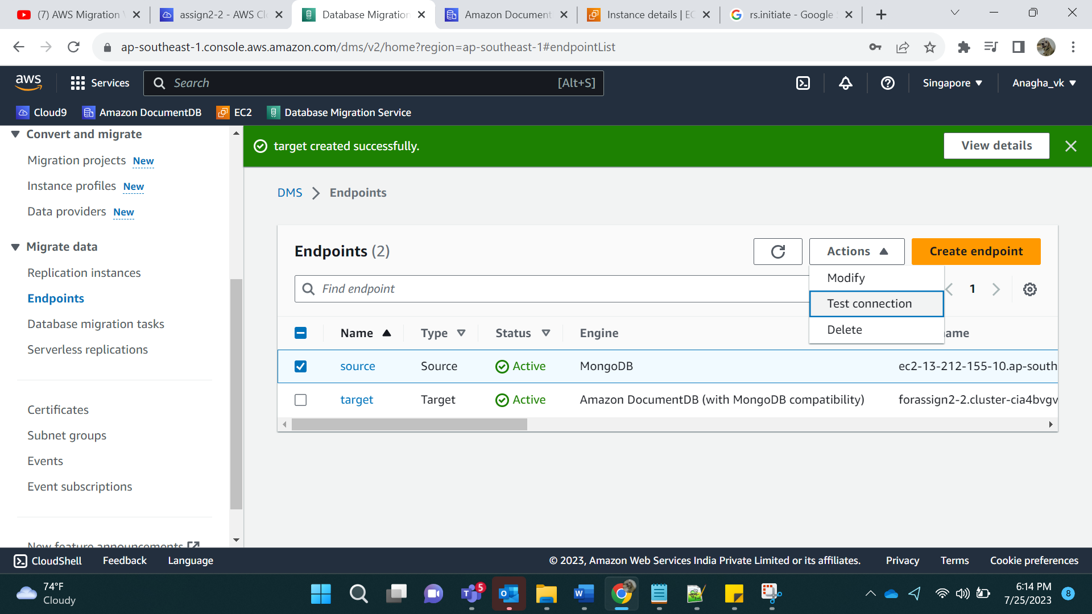

Error:

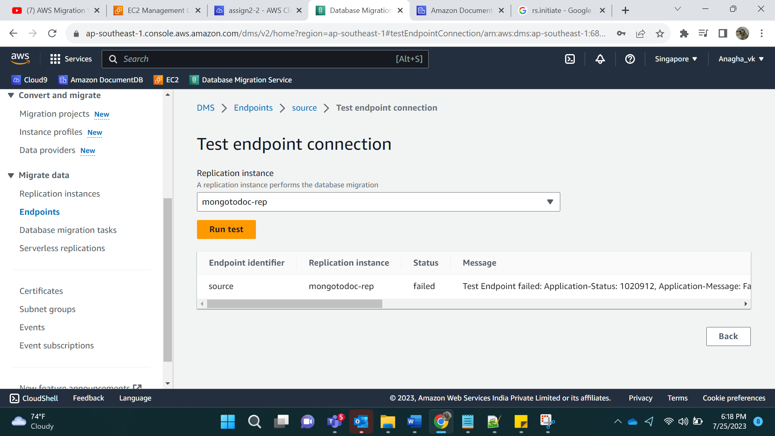

Add Inbound rules in EC2 instance security group:

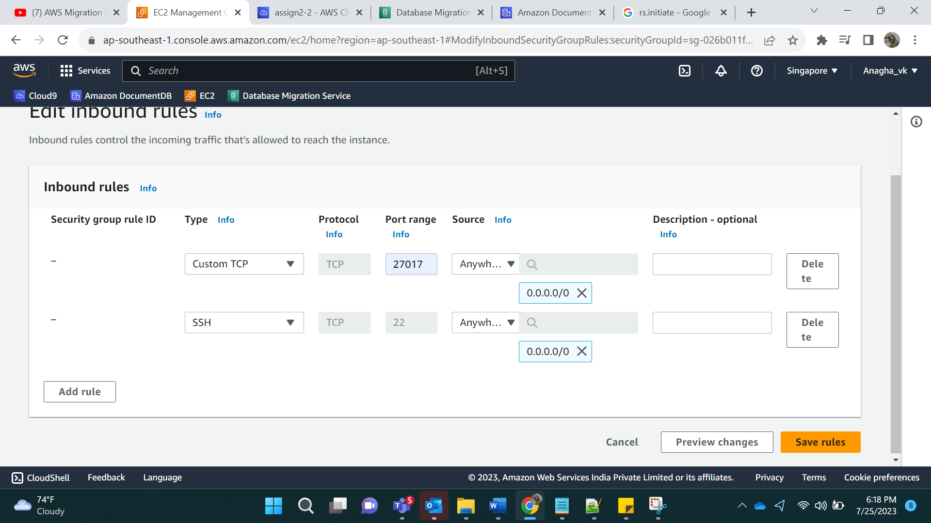

Run the task again

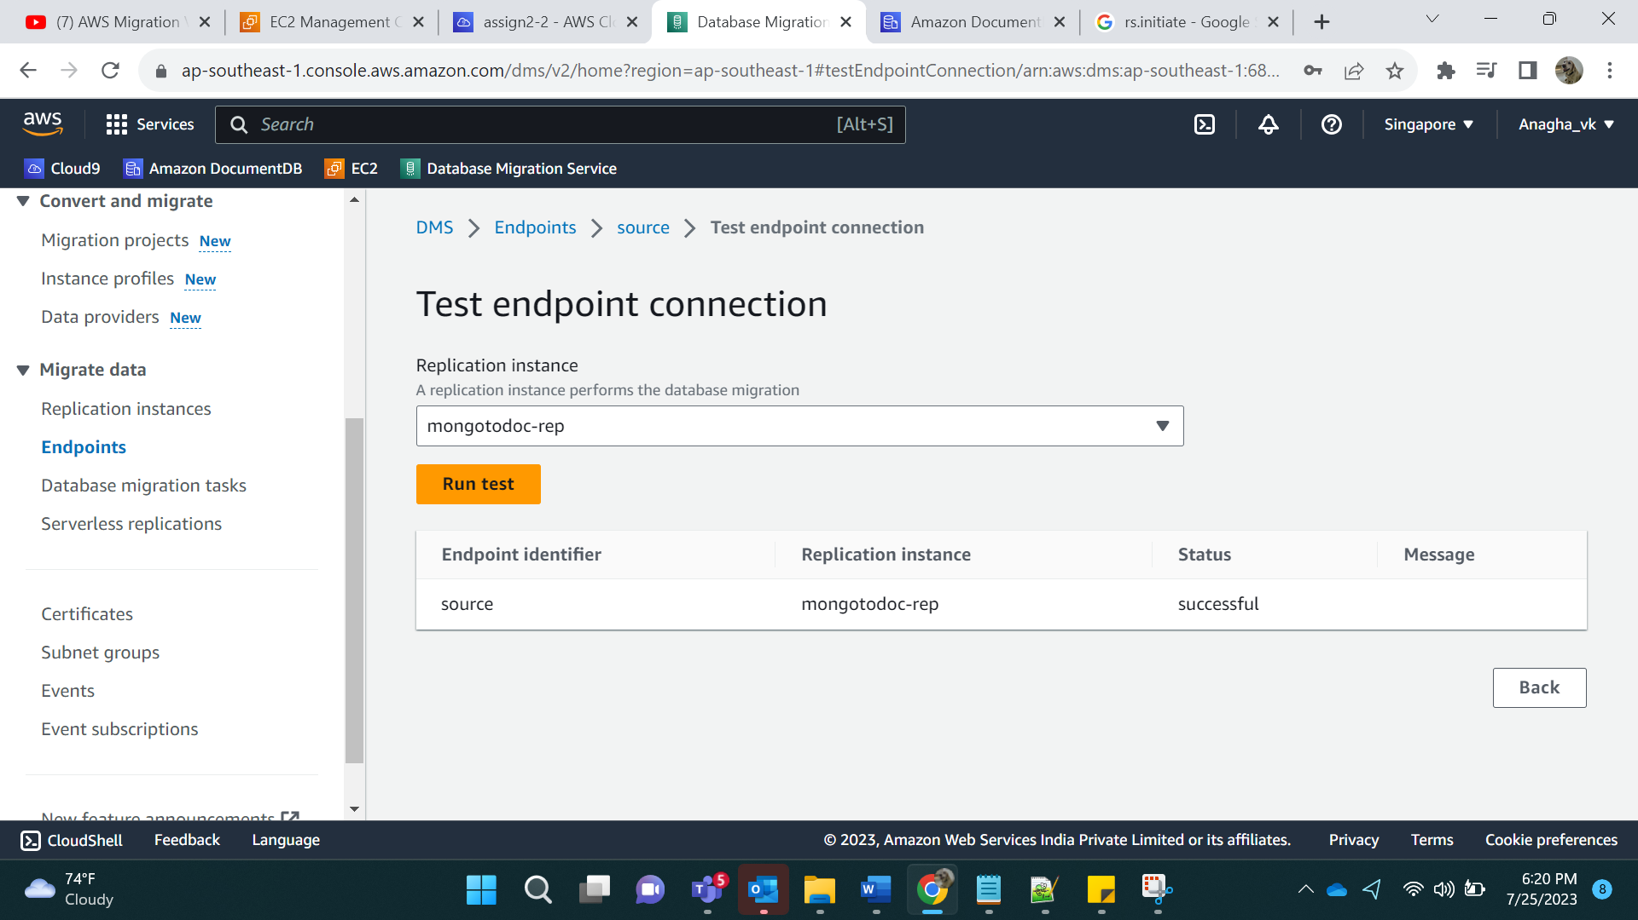

Testing target:

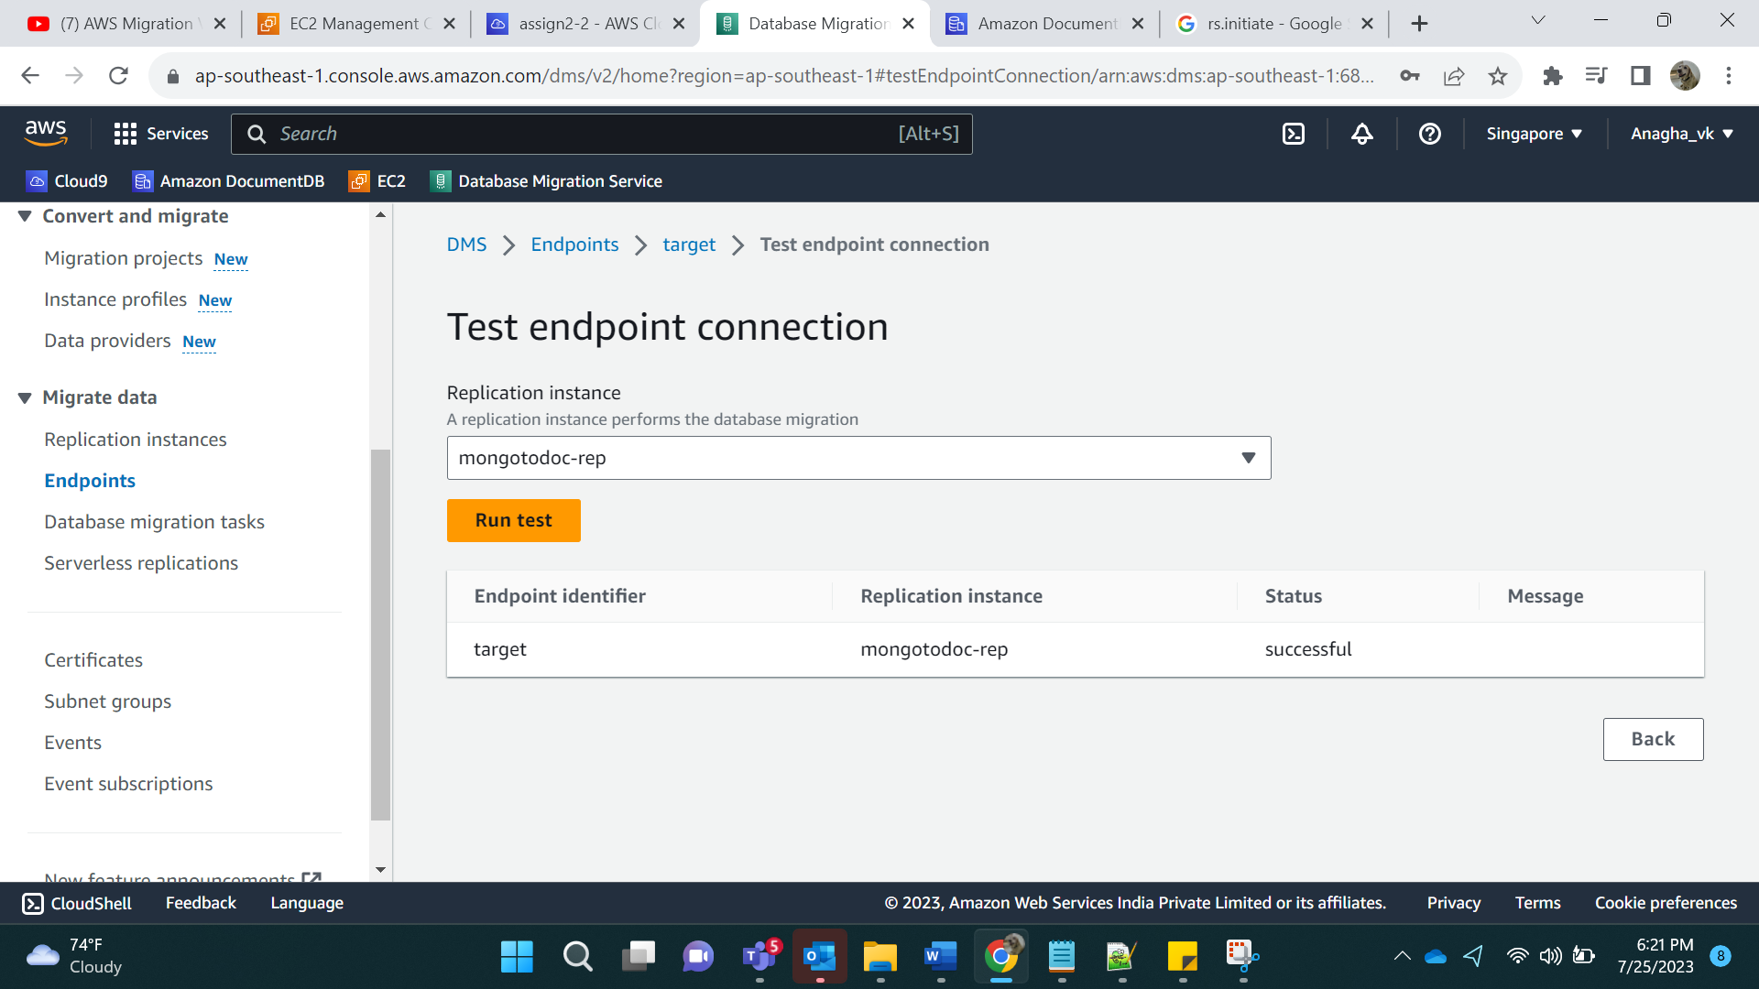

Step 17:

Create data migration task:

Task identifier: mongoToDocDB-task

Arn: mongoToDocDB-task

Relication instance: Created vpc in replication instance

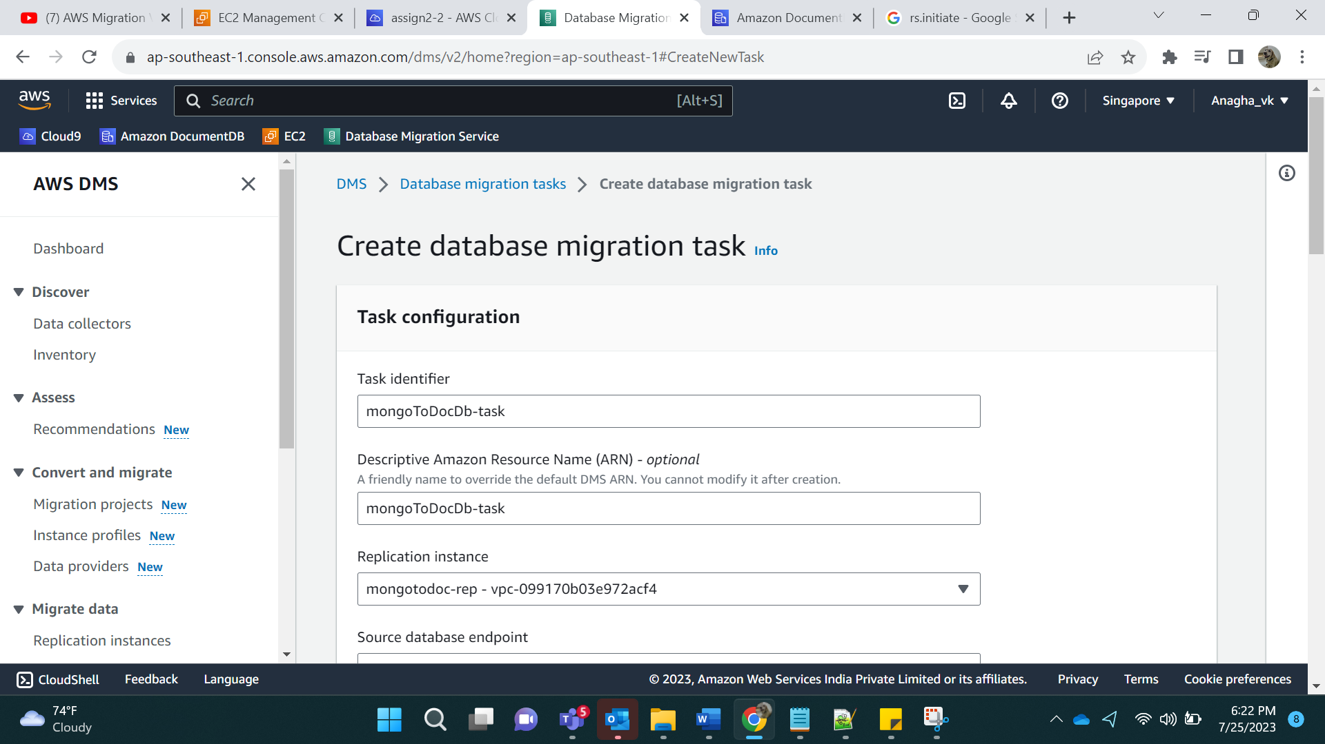

Souce DB Pt: source

Target DB Pt: target

Migration Type: Migrate existing Data and replicate ongoing Changes.

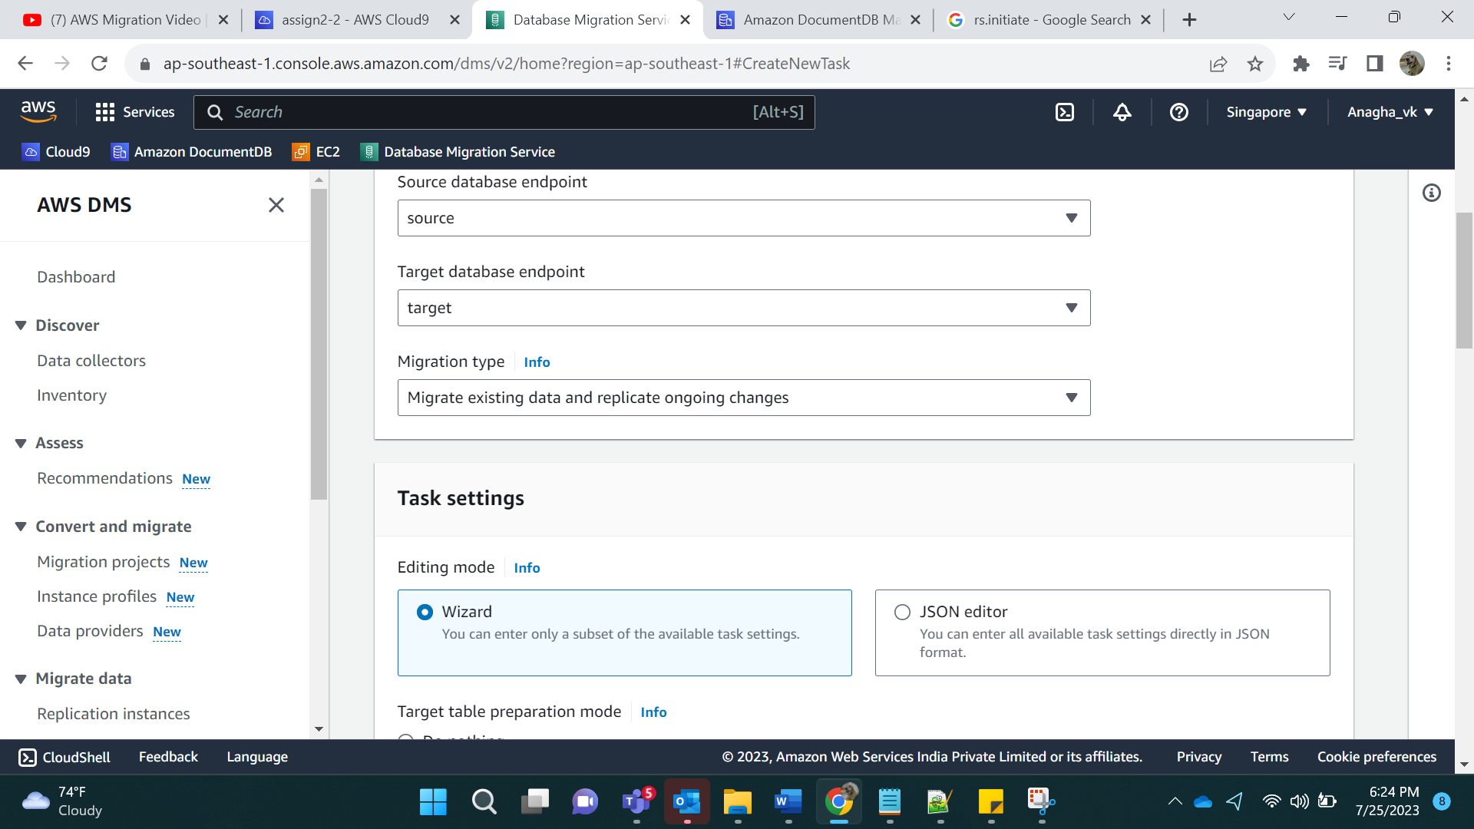

Enable cloudwatch:

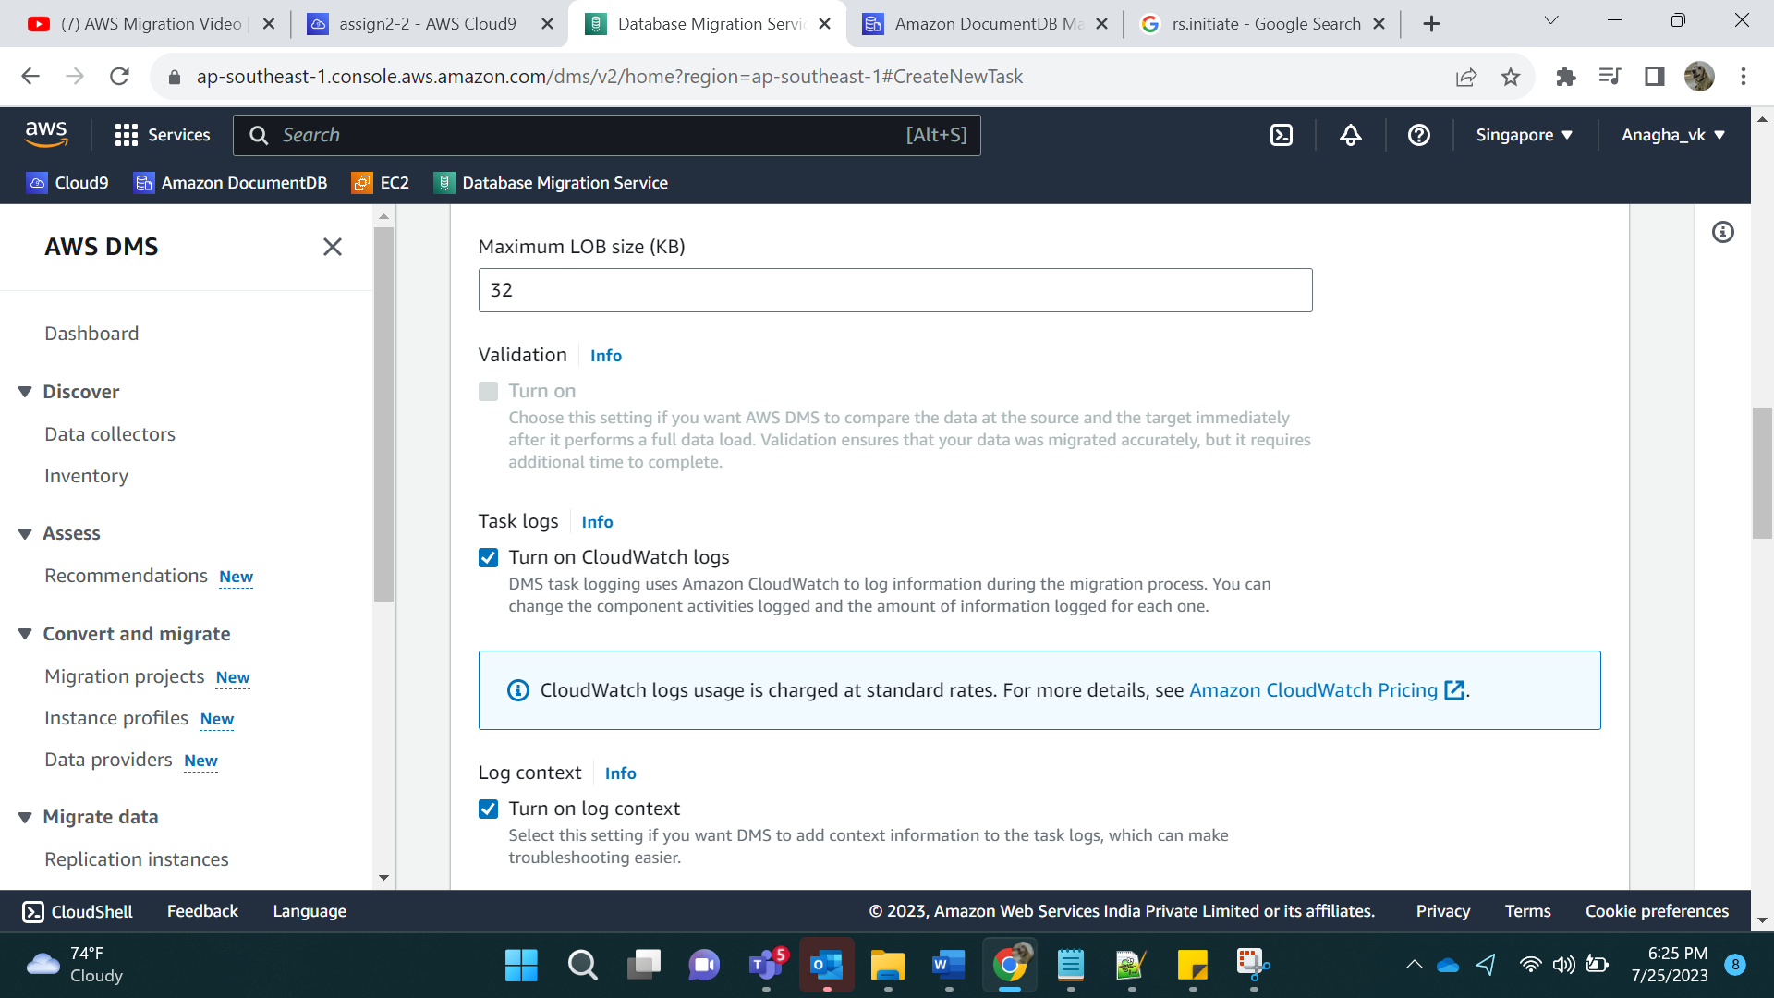

Selection Rules:

Add enter a schema. % is for all Databases.

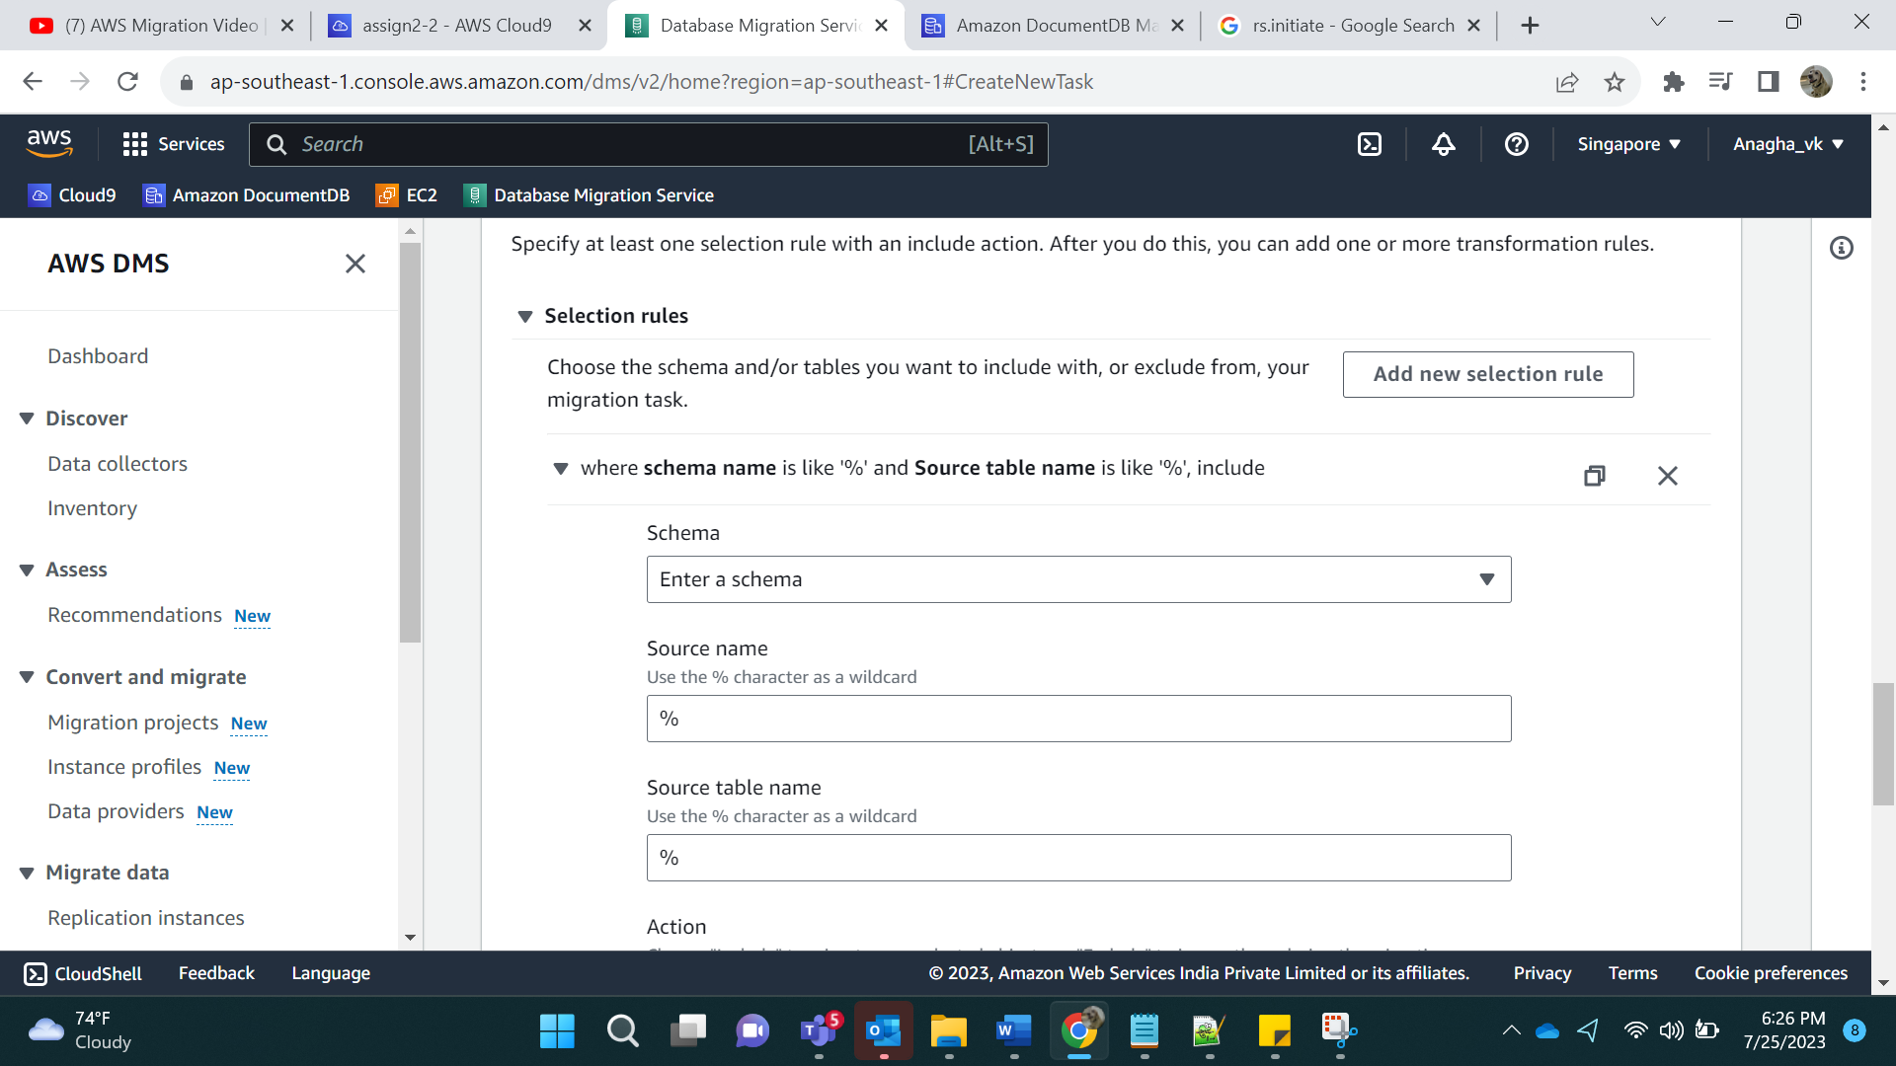

Create task:

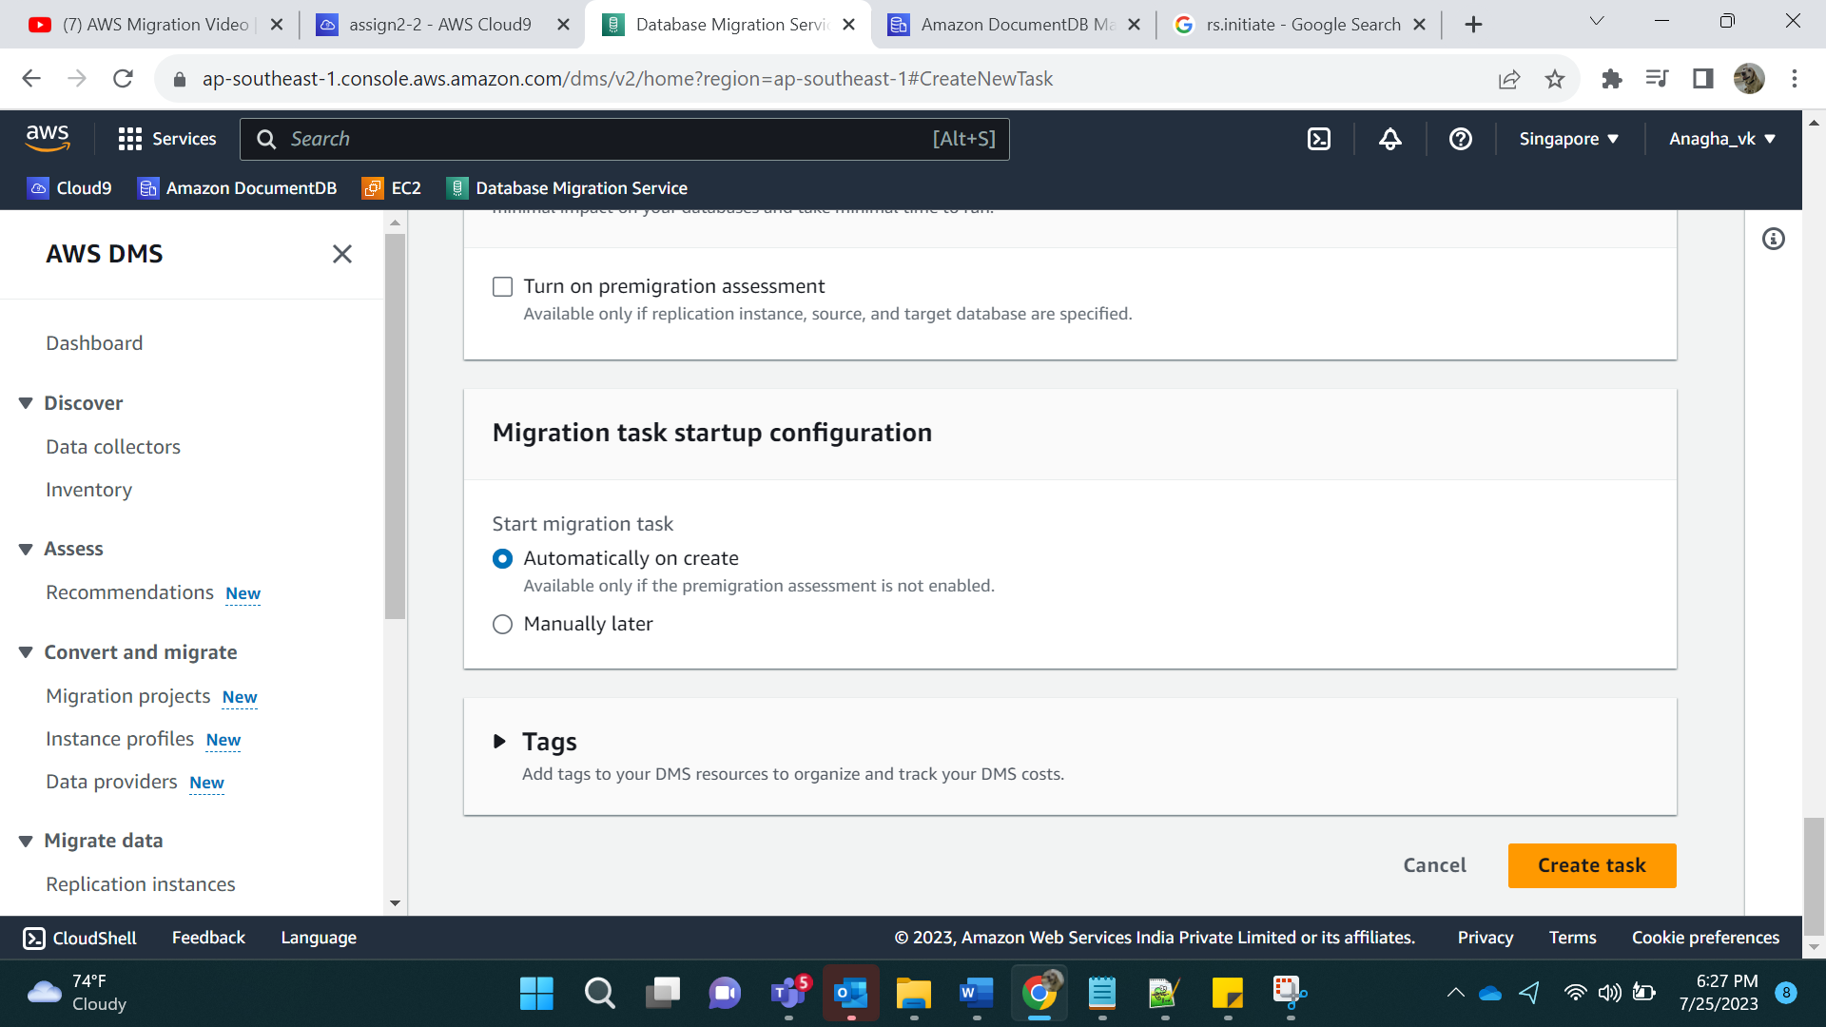

Result:

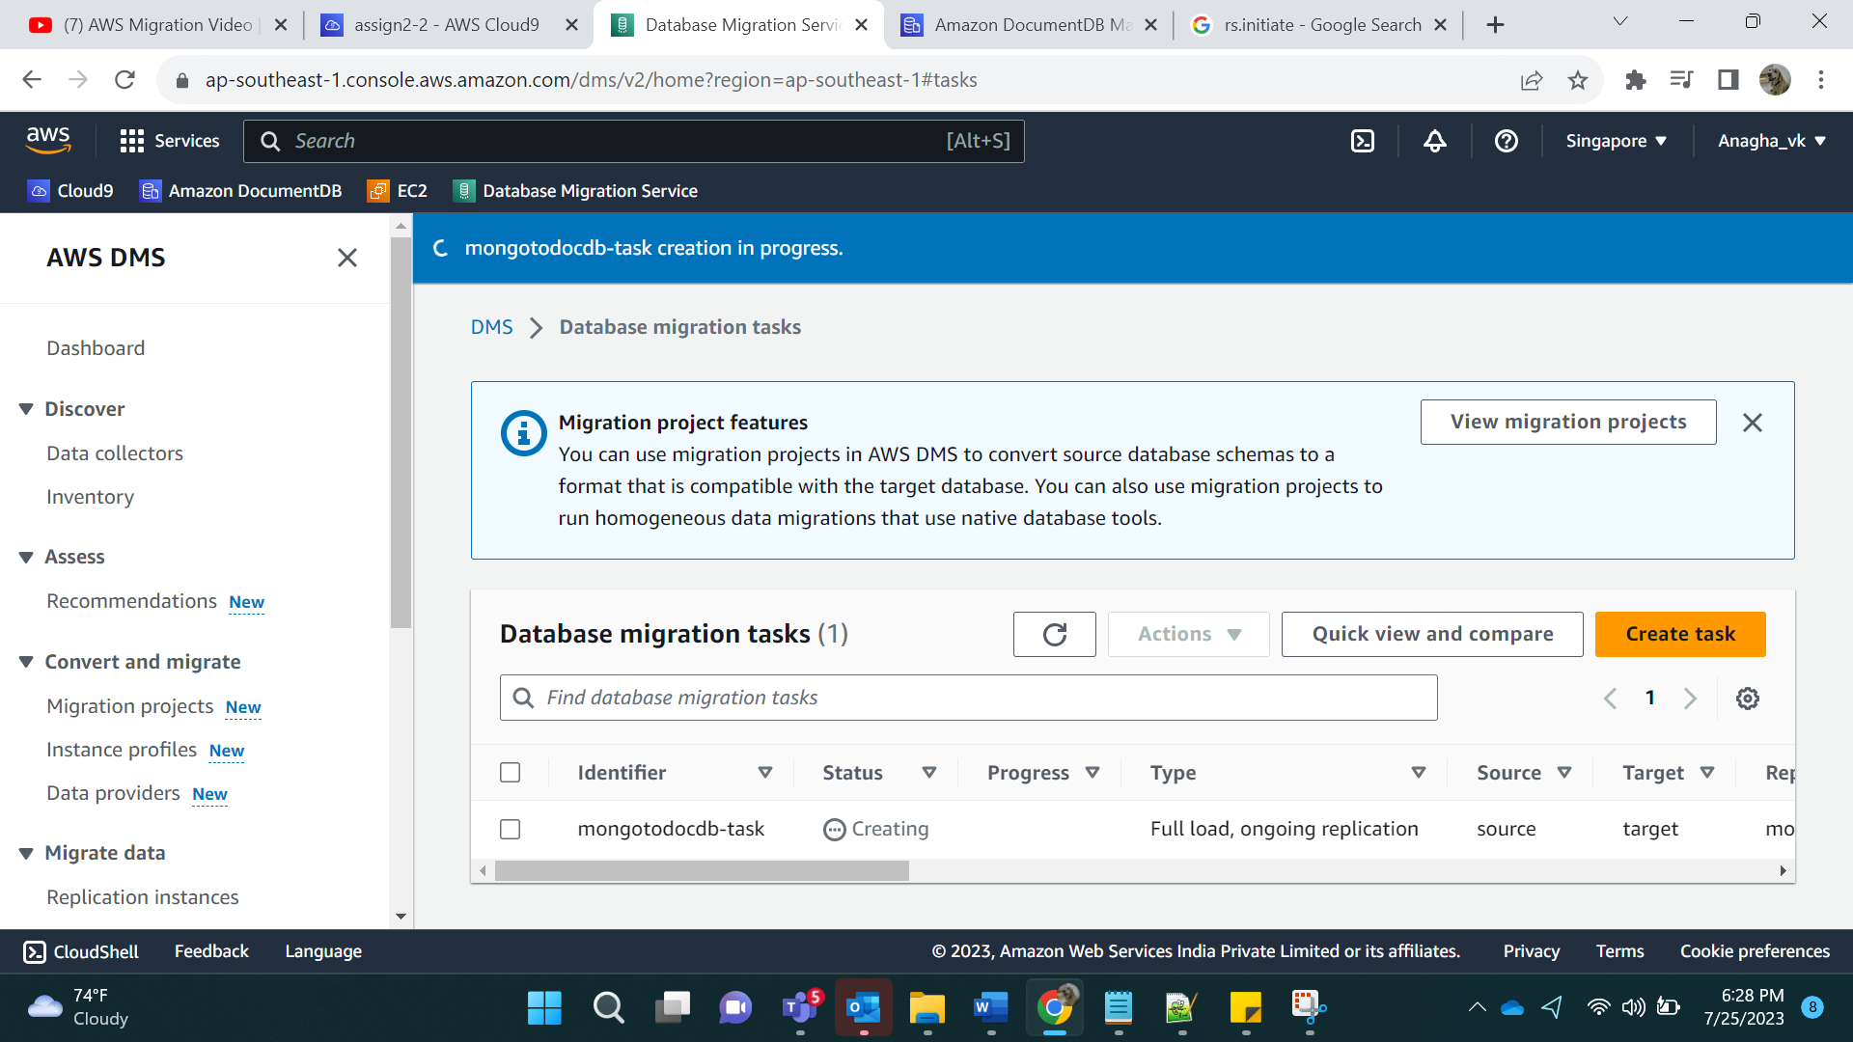

Click on table stats:

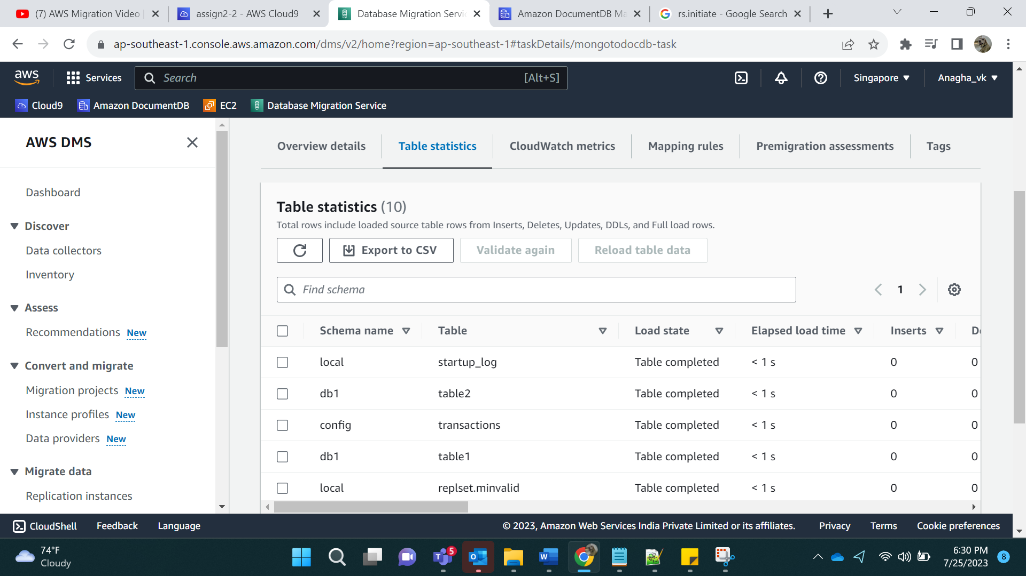

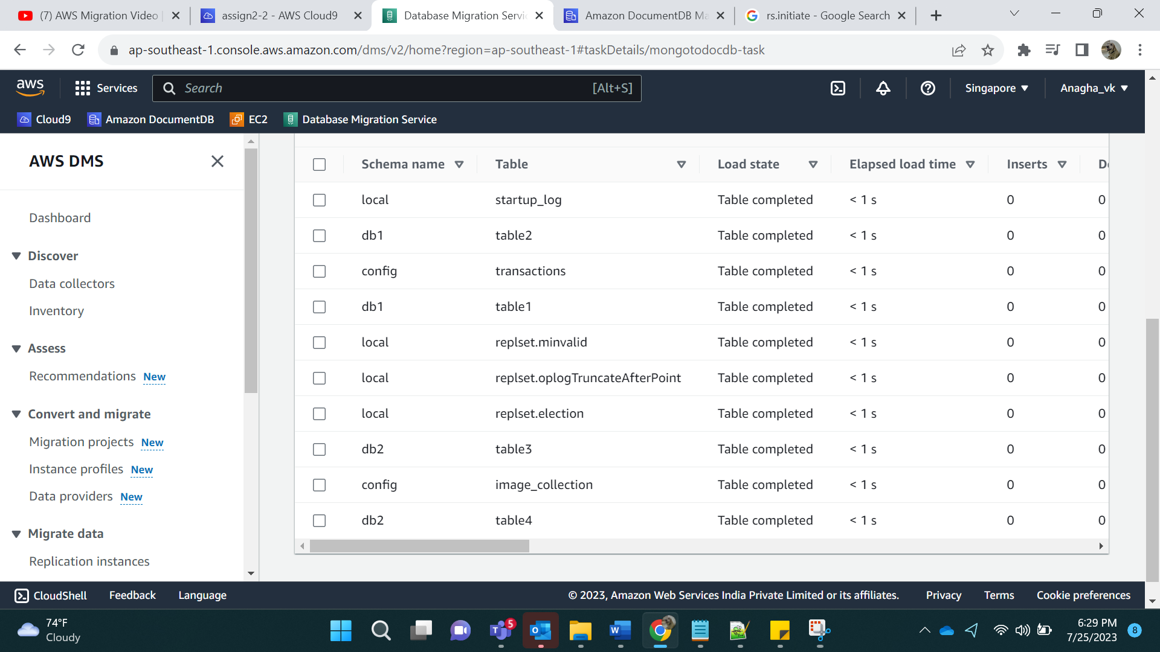

For 1 database All tables:

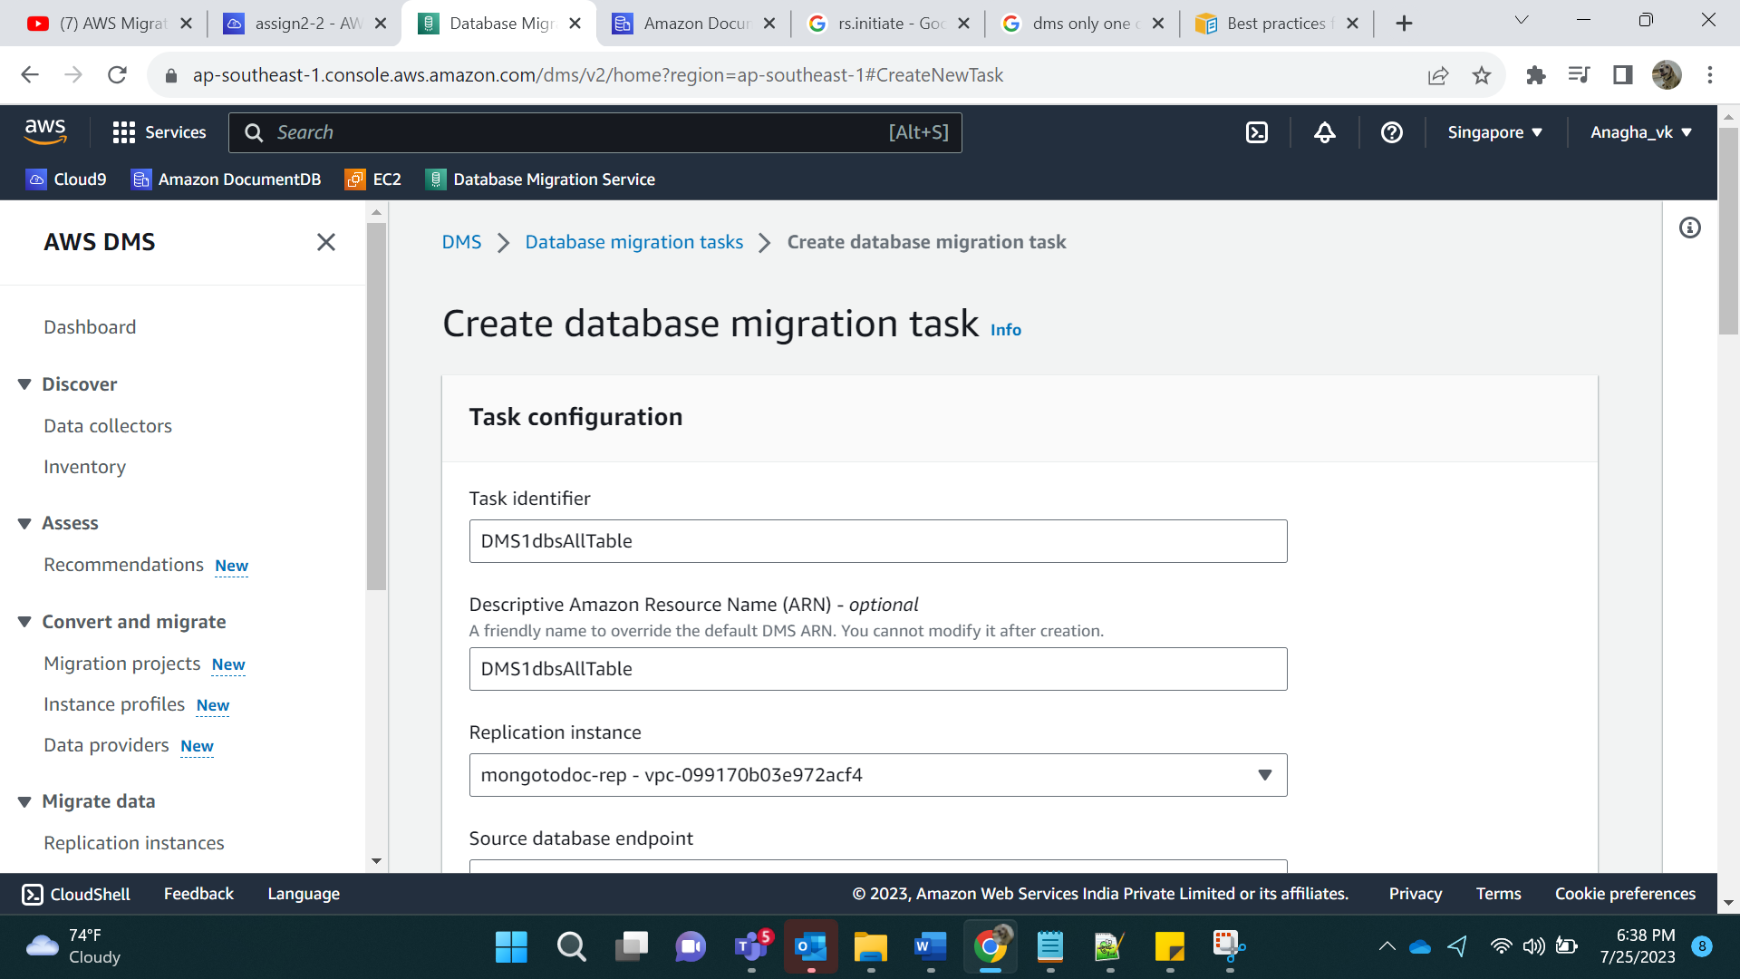

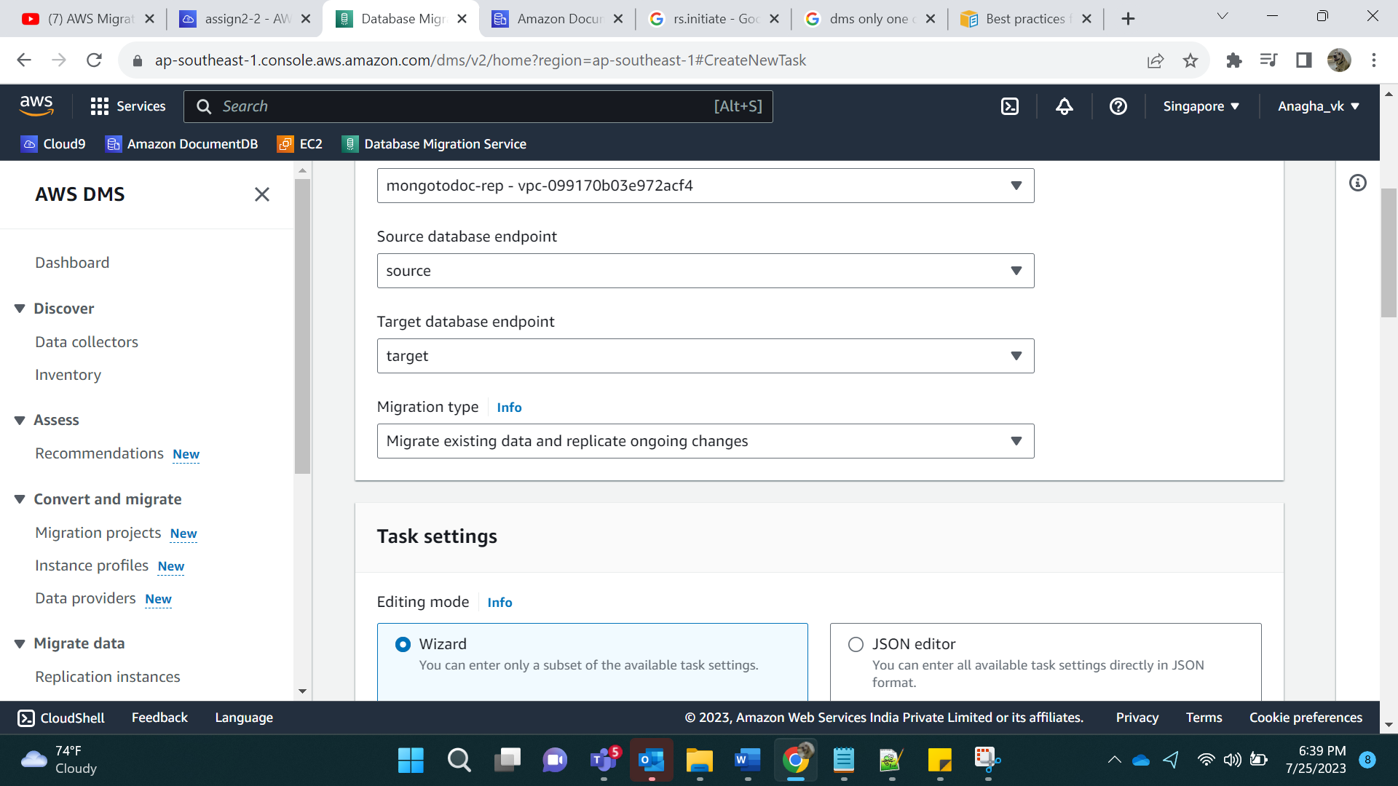

For Selection Rules:

Source Name: db1, all tables so %

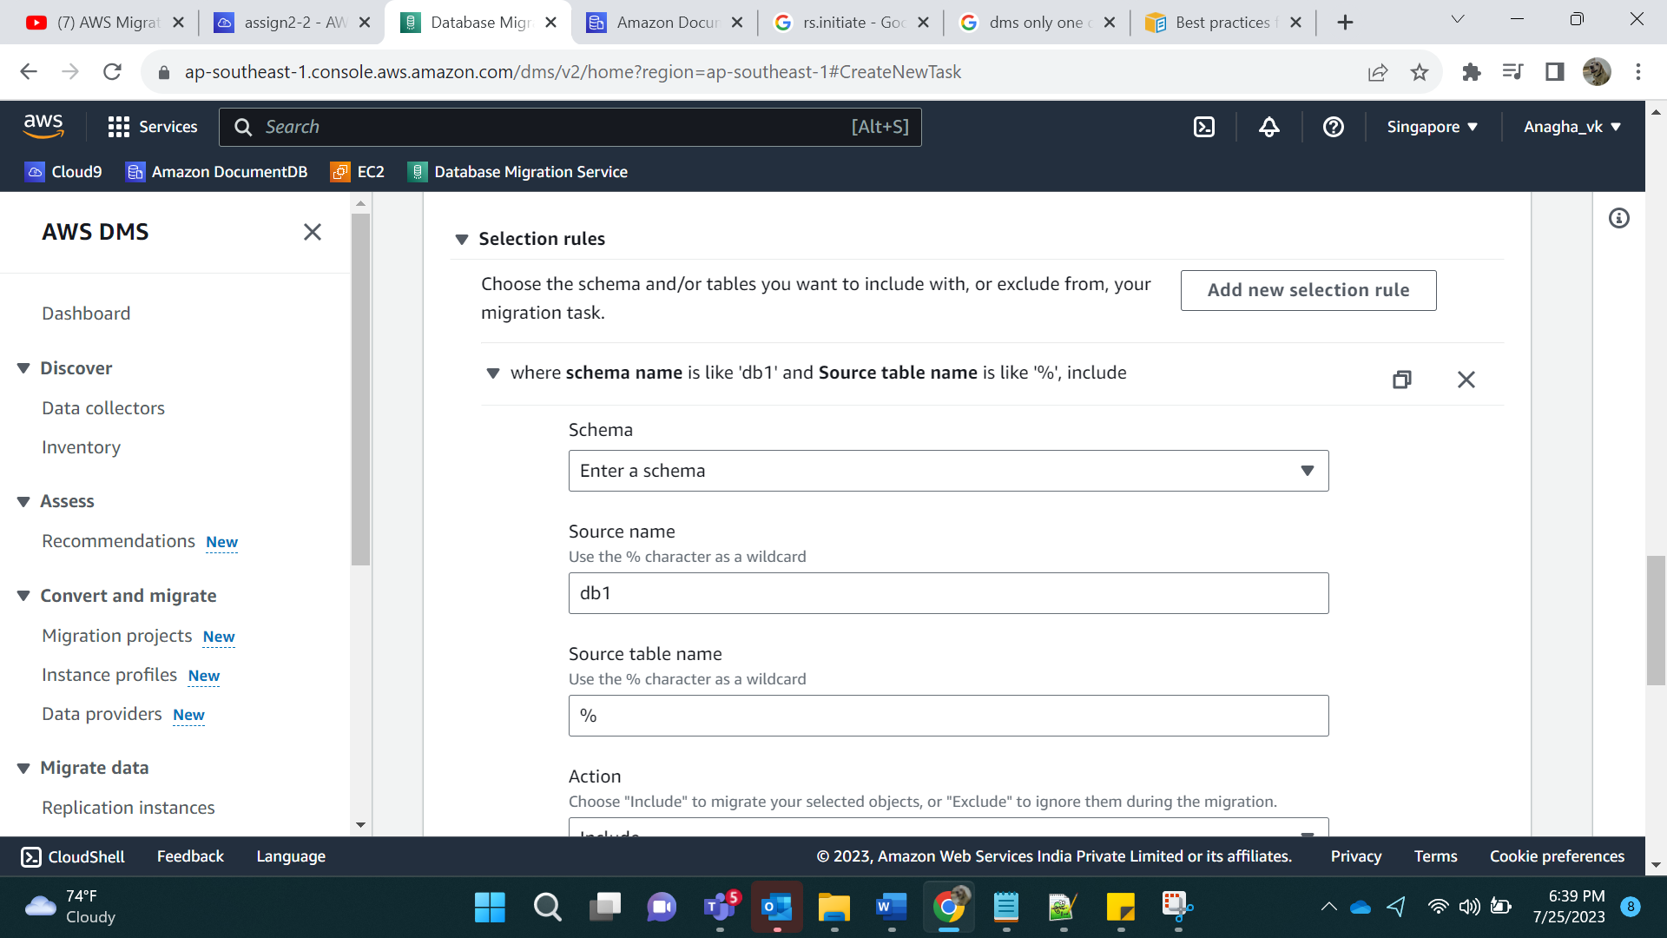

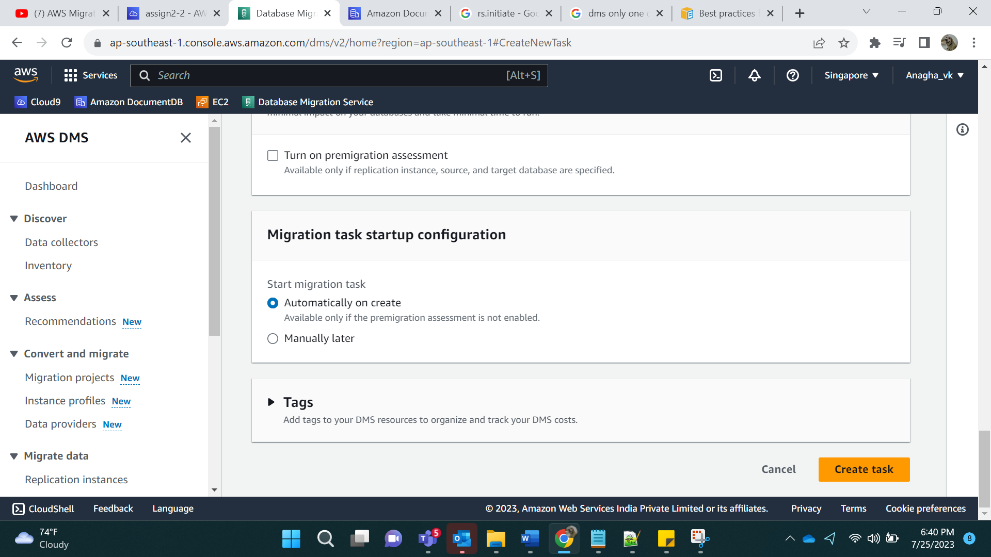

Output:

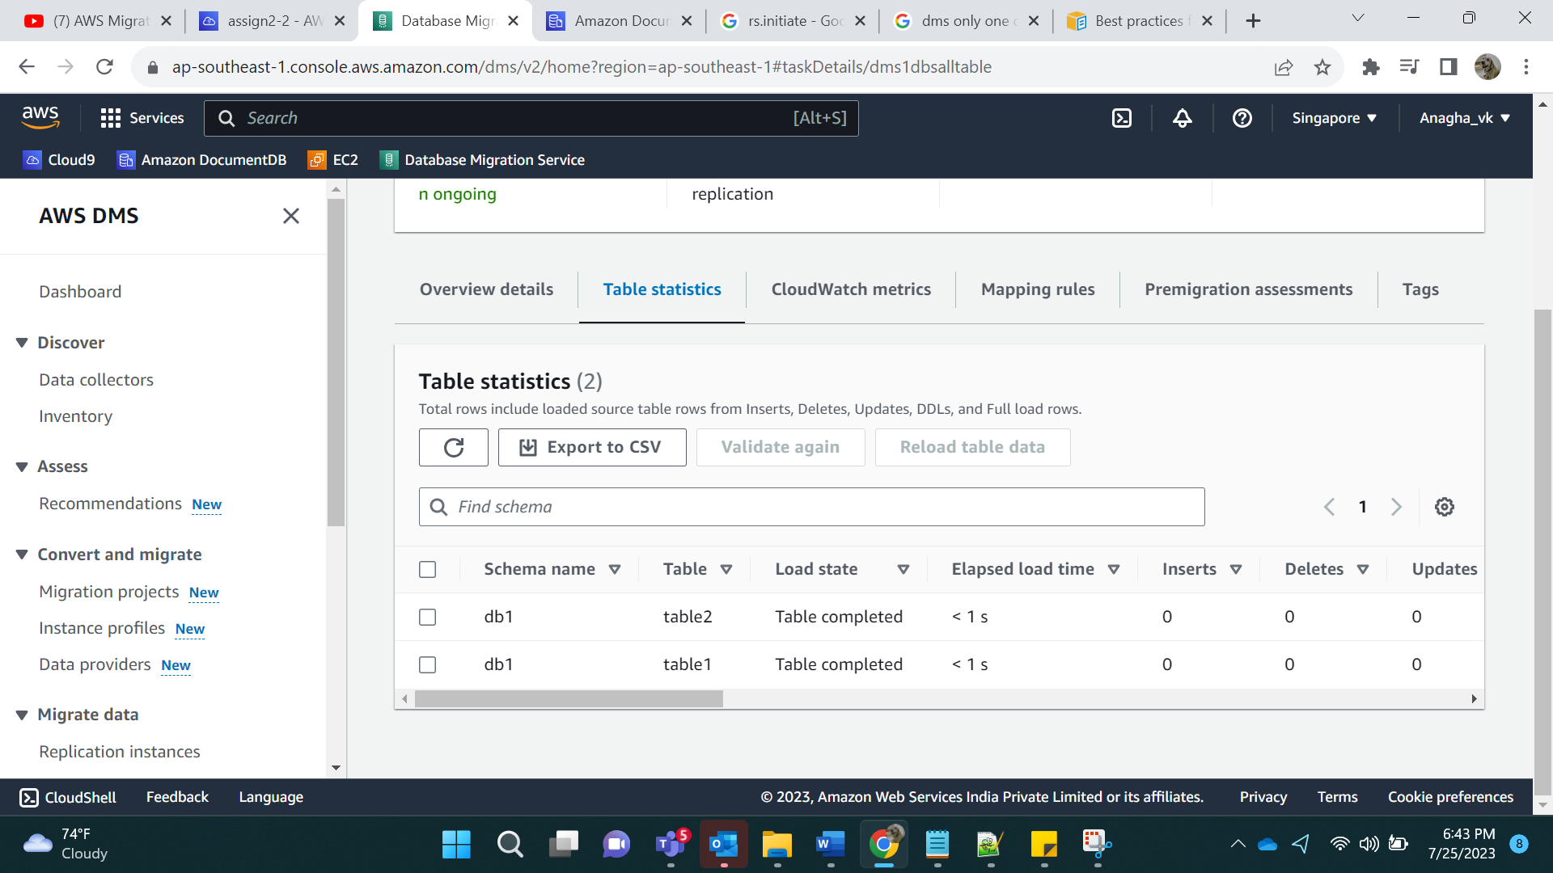

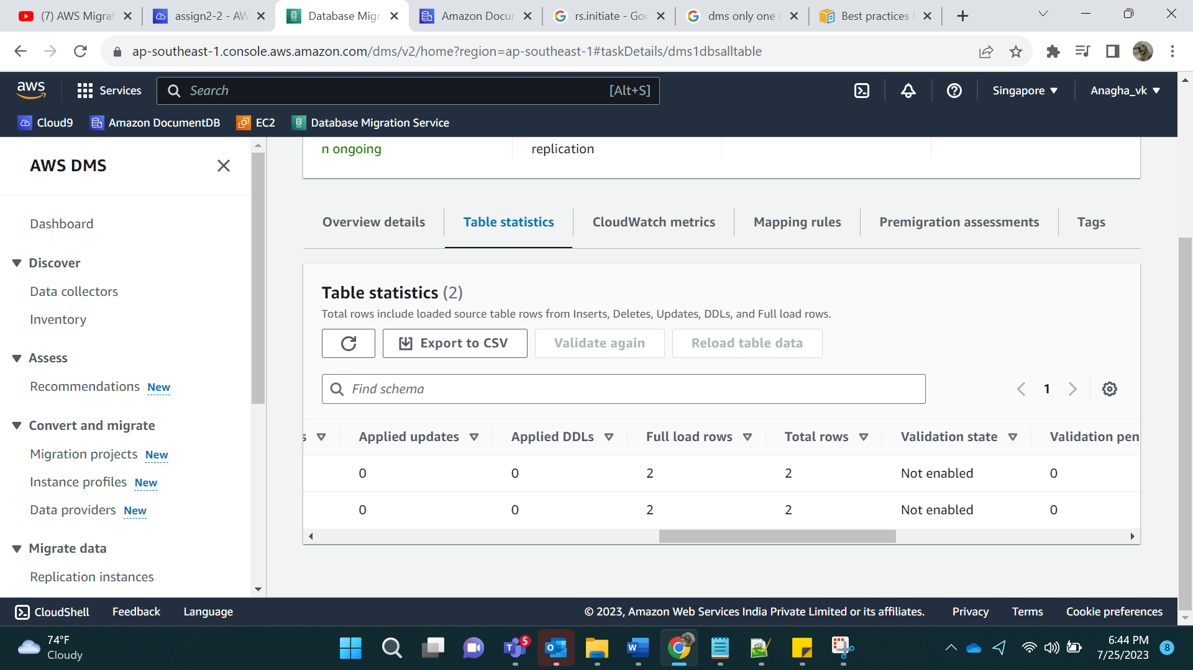

For 1 database and 1 table:

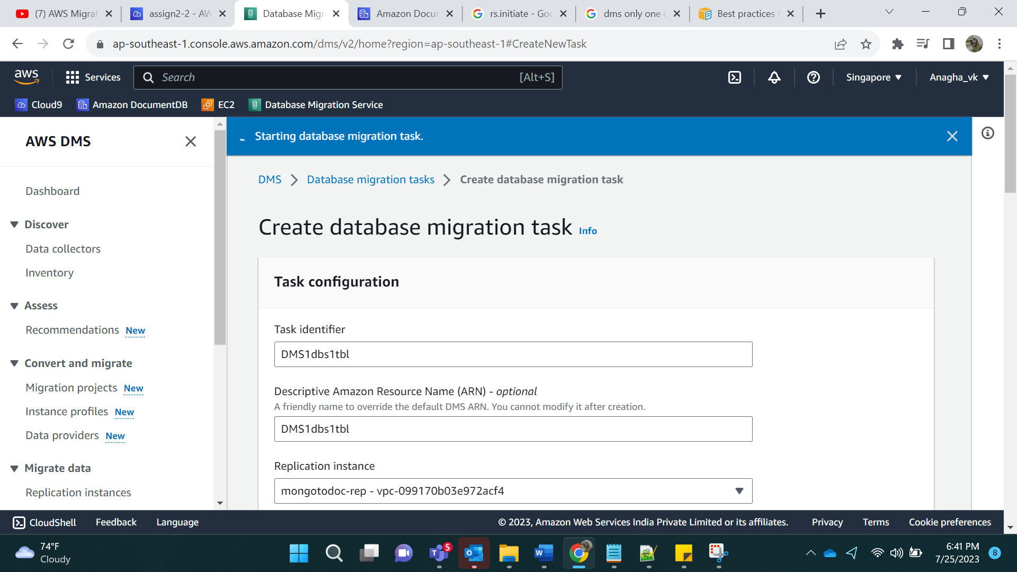

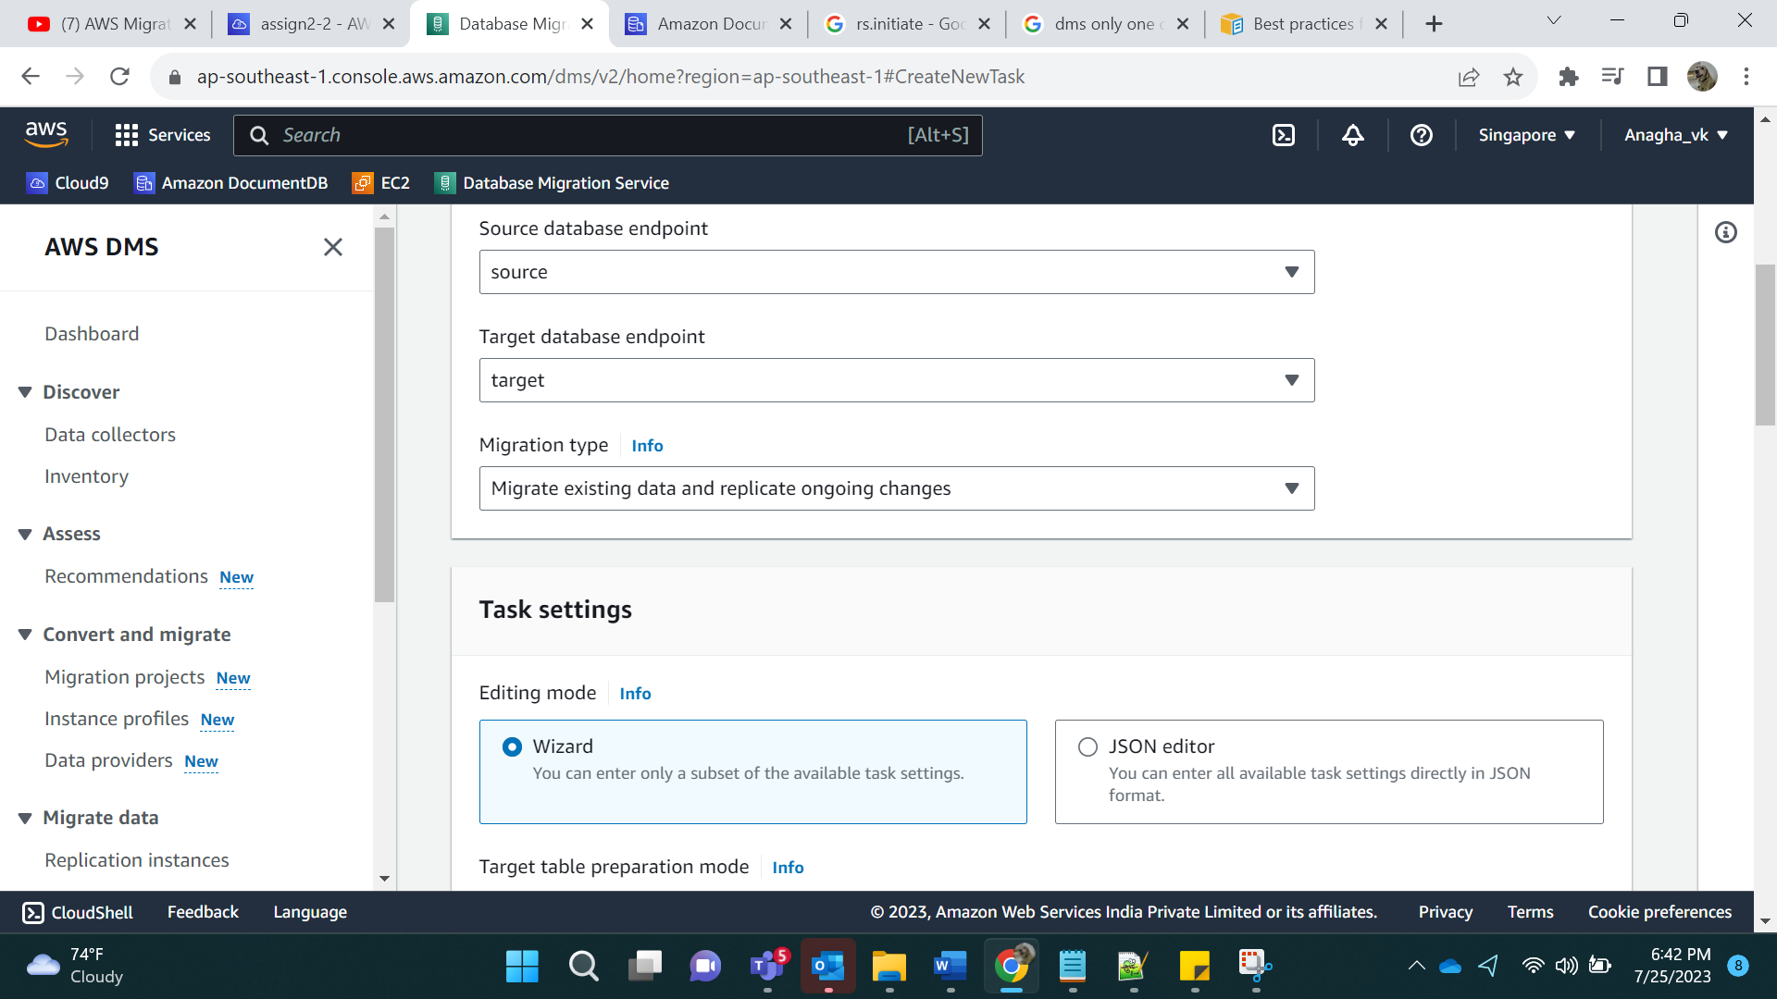

Source Name: db2

Table name: table3

